Exploratory Data Analysis 2

Project Description: 2

Project Title: 2

Objective: 2

Dataset: 2

Methodology: 3

Tools and Technologies: 3

Deliverables: 4

Descriptive Analysis 4

Project Description: 4

Project Title: 4

Objective: 4

Dataset: 4

Methodology: 4

Tools and Technologies: 5

Deliverables: 5

Conclusion 6

Diagnostic Analysis 6

Project Description: Diagnostic Analysis of Budget Allocation Changes in the City of Vancouver 6

Project Title: 6

Objective: 6

Background: 6

Dataset: 6

Methodology: 7

Tools and Technologies: 7

Deliverables: 8

Timeline: 8

Data Wrangling 8

Project Description: Data Wrangling for Budget Analysis at the City of Vancouver Project Title: Data Wrangling for Enhanced Budget and Funding Insights 8

Objective: 8

Background: 8

Dataset: 9

Methodology: 9

Tools and Technologies: 9

Deliverables: 10

Timeline: 10

# Exploratory Data Analysis

Project Description: Exploratory Data Analysis (EDA) on Titanic Dataset

Project Title: Surviving the Titanic: An Exploratory Data Analysis

Objective: The primary objective of this project is to analyze the City of Vancouver's 2023-2026 Capital Plan and 2023 Capital Budget datasets to uncover patterns and trends in budget allocation. By examining various budget categories, such as infrastructure, parks, and transportation, we aim to understand the city's financial priorities and provide actionable insights to improve decision-making and urban planning.

Dataset: The dataset consists of budgetary data from the City of Vancouver, including details such as:

Capital Category: Key areas of budget allocation (e.g., housing, transportation, parks).

Project Description: Details about funded projects.

Estimated Cost: Total cost associated with each project.

Funding Source: Sources contributing to the budget (e.g., reserves, external funding).

Allocation Year: Year-by-year budget allocation across categories.

## Methodology:

1. Data Collection and Preparation:

* Load the budget data into Amazon S3 for centralized storage.
* Use AWS DataBrew for data profiling and initial cleaning, such as handling missing values and renaming columns for consistency.

1. Descriptive Statistics:
   * Generate summary statistics for budget categories to identify key trends (e.g., top-funded areas).
   * Calculate total and average funding across years for each capital category.
2. Data Visualization:
   * Create visualizations to illustrate key insights:
     + Histograms and Boxplots: Analyze the distribution of continuous variables like Age and Fare.
     + Bar Charts: Showcase survival rates across different categories (e.g., Sex, Pclass).
     + Heatmaps: Visualize correlations between numerical variables.
3. Survival Analysis:
   * Compare survival rates:
     + Create visualizations to highlight budget trends and priorities:
     + Bar Charts: Show budget allocations by category and year.
     + Pie Charts: Illustrate proportions of funding sources.
     + Heatmaps: Highlight correlations between categories and funding levels.
4. Insights and Findings:
   * Identify major areas of spending and how they align with the city's priorities (e.g., housing and community infrastructure).
   * Examine changes in allocation over the years to assess evolving priorities.
5. Conclusion:
   * Provide recommendations for optimizing budget allocations to address emerging urban challenges, such as population growth and sustainability.

## Tools and Technologies:

* AWS S3: Centralized data storage for raw and cleaned datasets.
* AWS DataBrew: Data profiling and cleaning.
* Python (Pandas, Matplotlib, Seaborn): Descriptive statistics and data visualization.
* Tableau: Advanced dashboards and visualization for stakeholders.

## Deliverables:

* A detailed report summarizing budget trends and insights.
* Dashboards and visualizations to present key findings clearly.
* Recommendations for the city’s future budgeting strategies.
* A detailed report summarizing the project’s methodology, findings, and recommendations.
* Dashboards for visualizing key metrics, such as budget distribution by category and region, funding trends, and allocation variances.

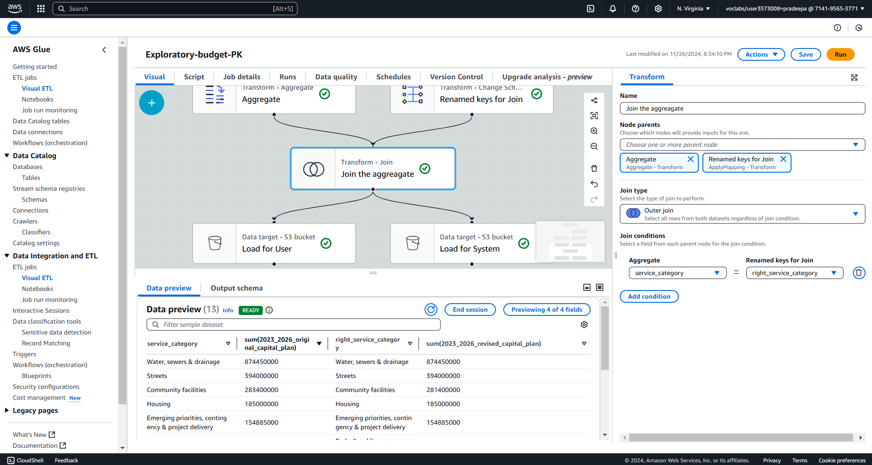

Data Output:

Saved the transformed data in two formats:

CSV format for user-friendly access in the user S3 bucket.

Parquet format in a system bucket for optimized storage and computational efficiency.

This pipeline ensures that the data is clean, structured, and ready for analysis while maintaining high performance and scalability.

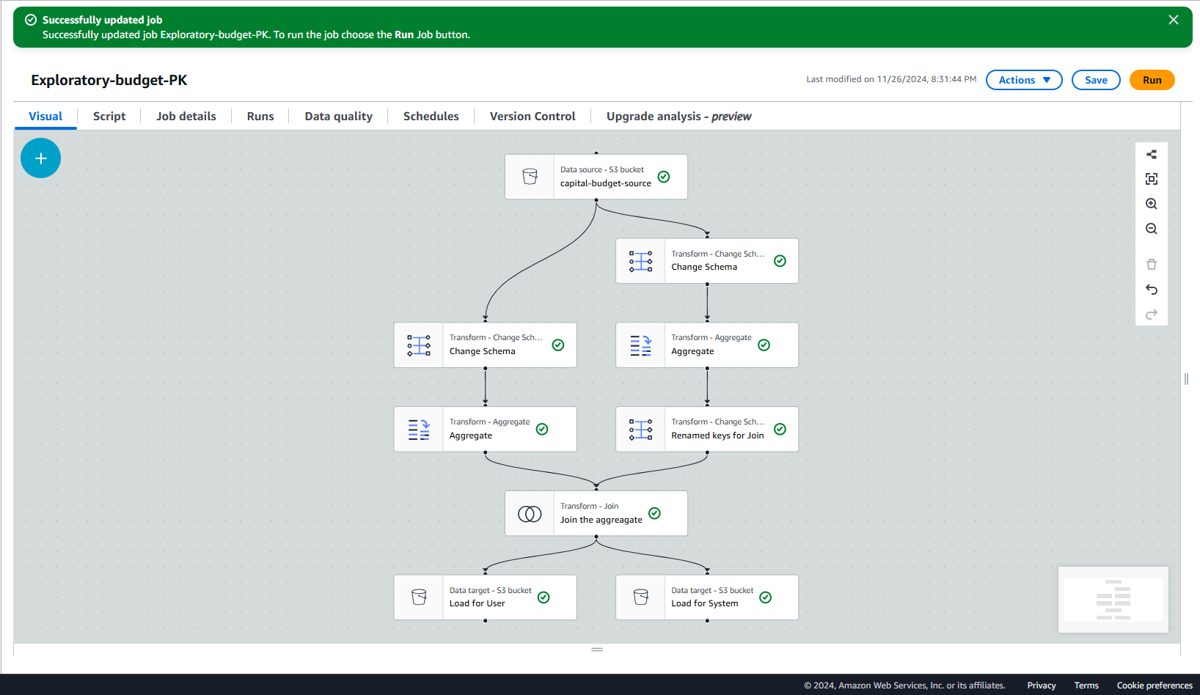

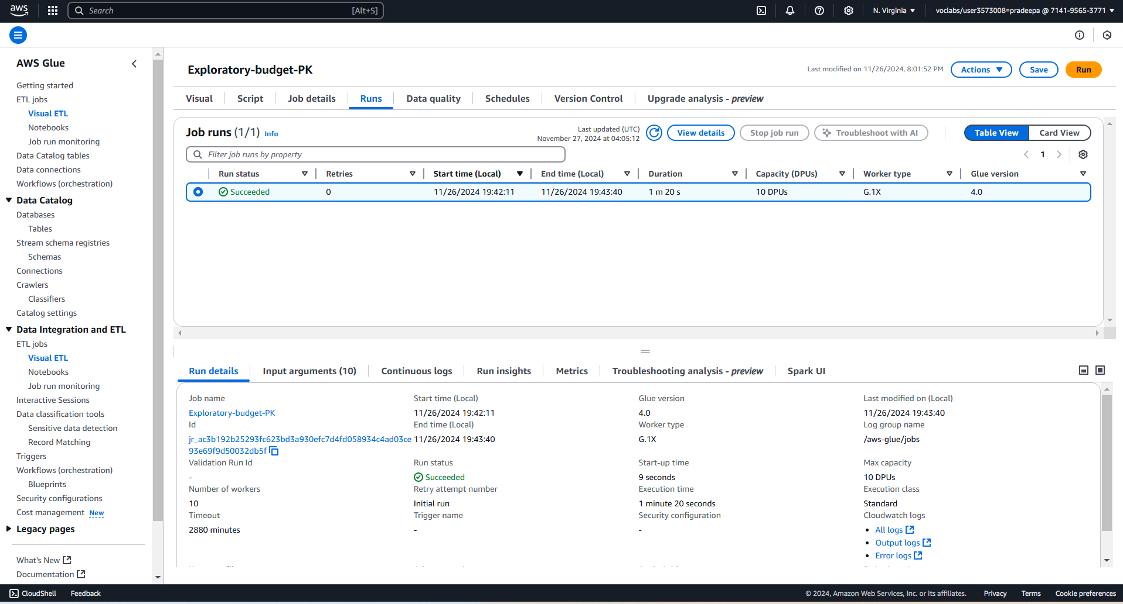

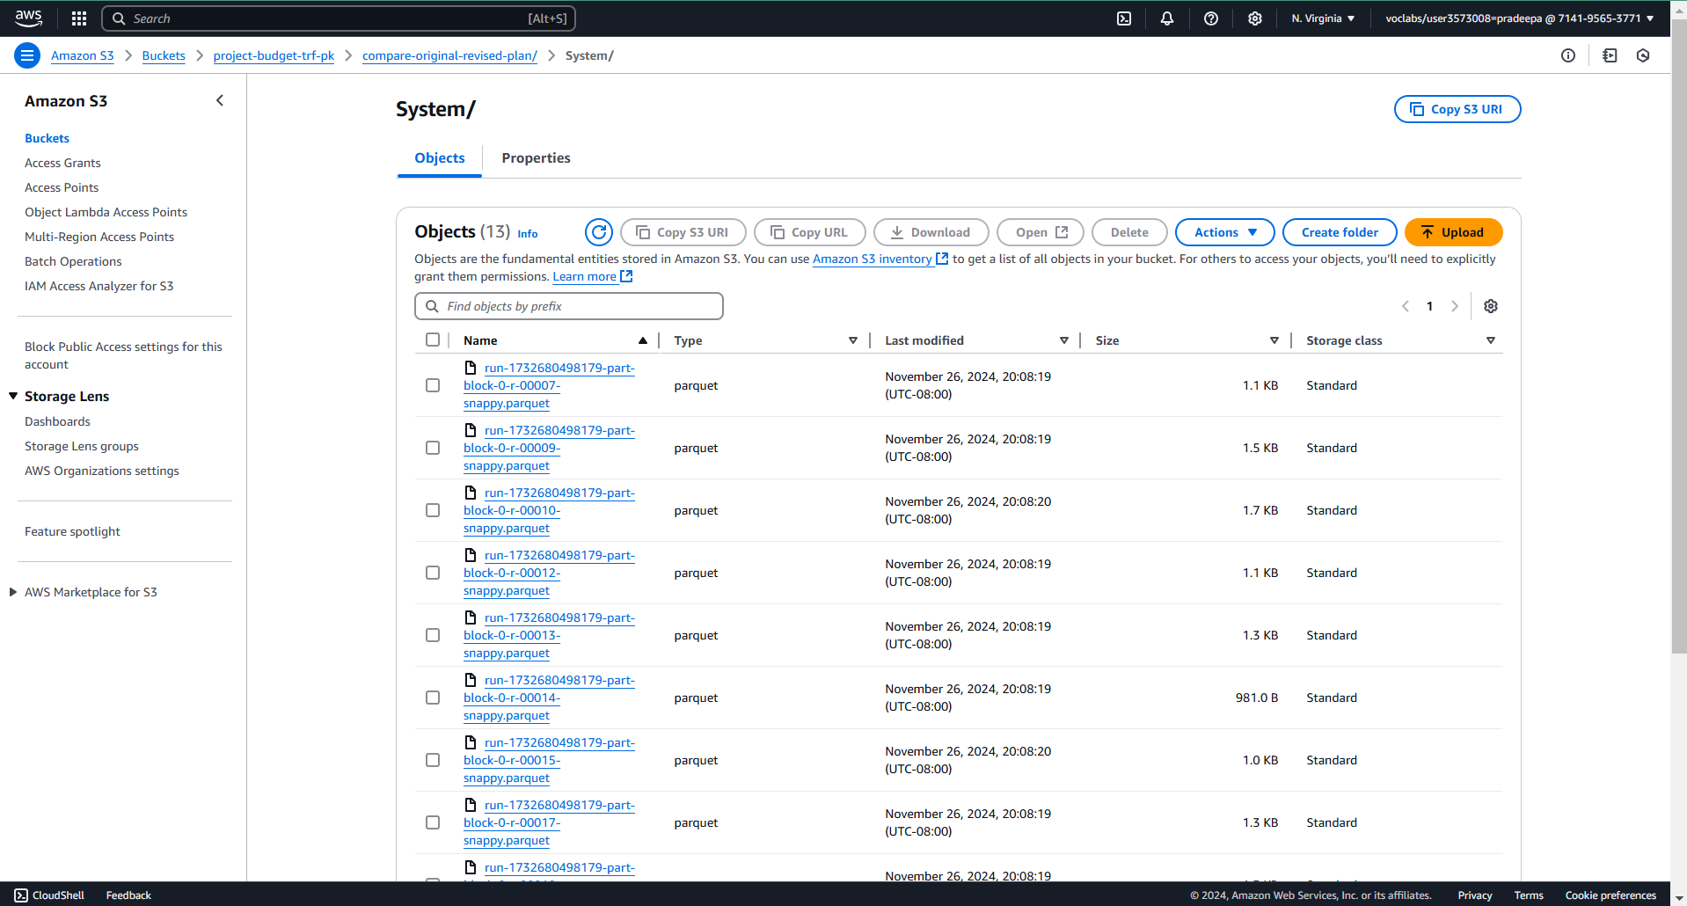

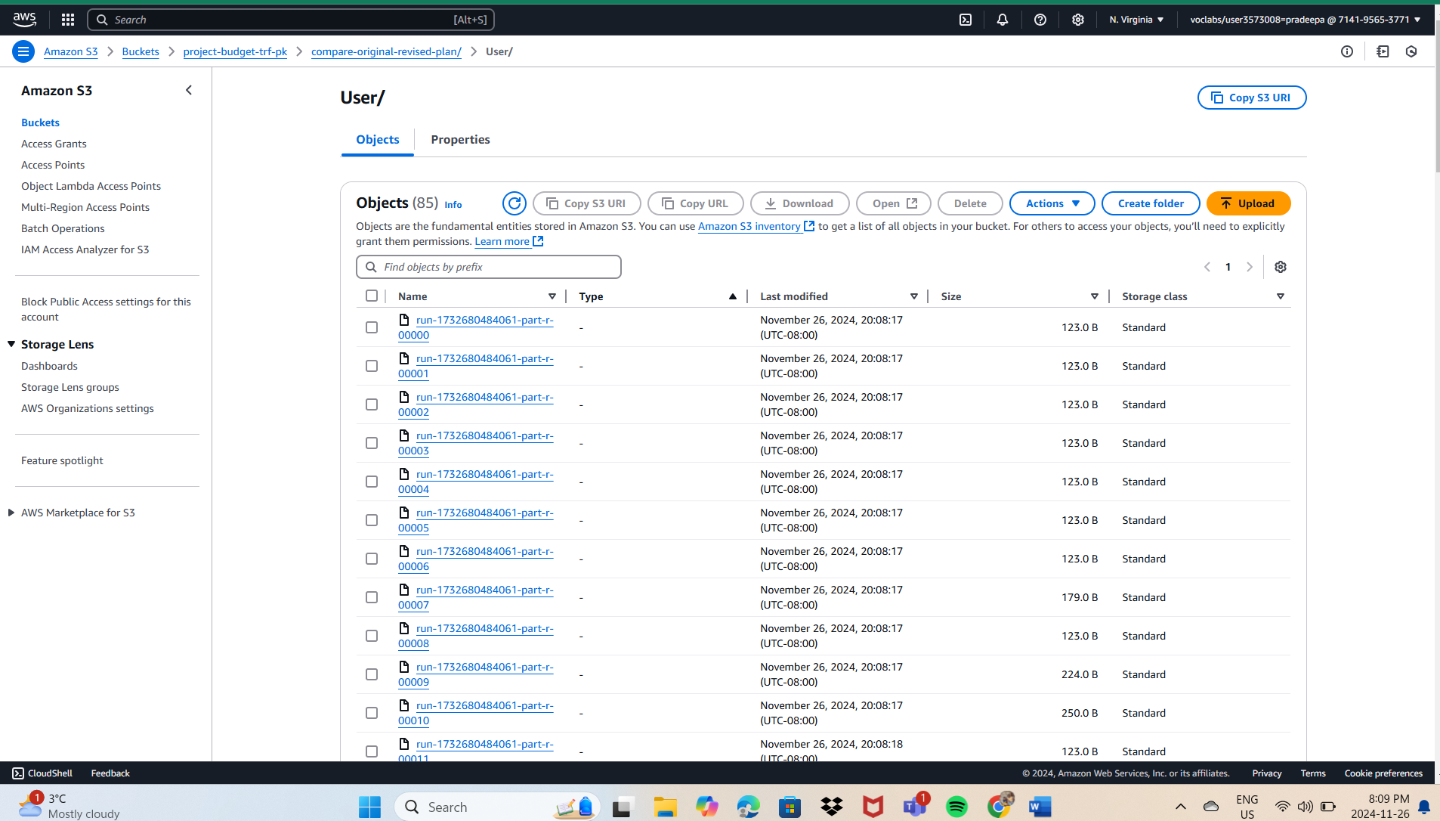

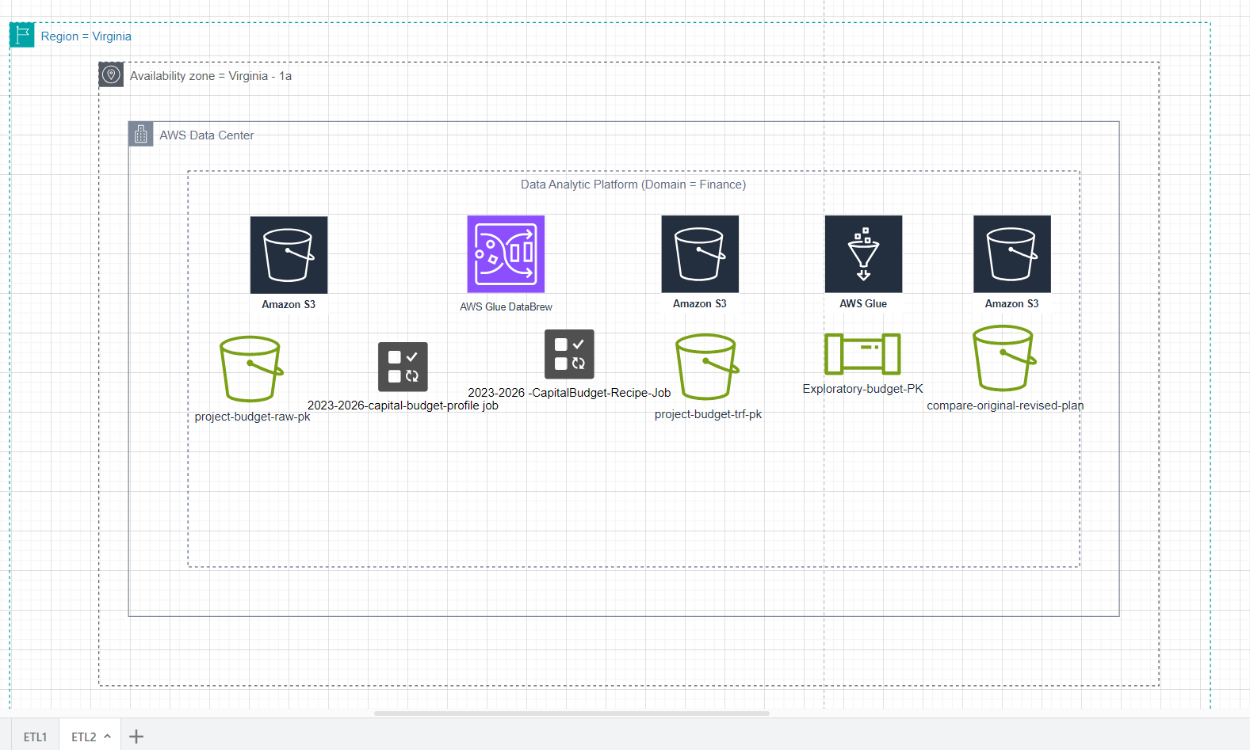

# Descriptive Analysis

Project Description: Descriptive Analysis of the City of Vancouver's Capital Budget and Funding Allocations.

Project Title: Understanding Budget Priorities and Funding Trends in Vancouver’s Capital Plan (2023–2026).

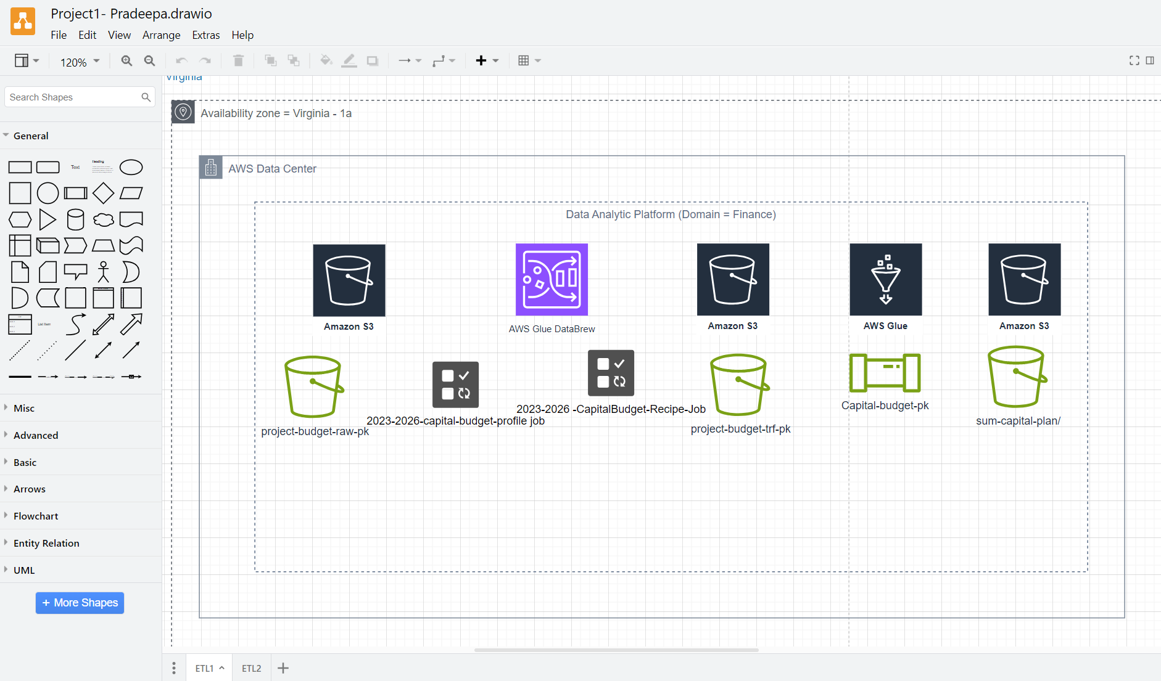

Objective: The objective of this project is to conduct a descriptive analysis of the City of Vancouver’s budget allocations. This analysis summarizes expenditure trends, identifies key investment areas, and highlights shifts in funding priorities over time to inform decision-making and resource allocation strategies.

Dataset: The dataset consists of budgetary data for capital projects in Vancouver, with key features including:

Project Category: Infrastructure, parks, transportation, etc.

Budget Allocation Year: 2023, 2024, 2025, 2026.

Funding Sources: External funding, reserves, or city revenues.

Project Costs: Estimated costs associated with specific initiatives.

Regional Allocations: Funding distribution across different areas of the city.

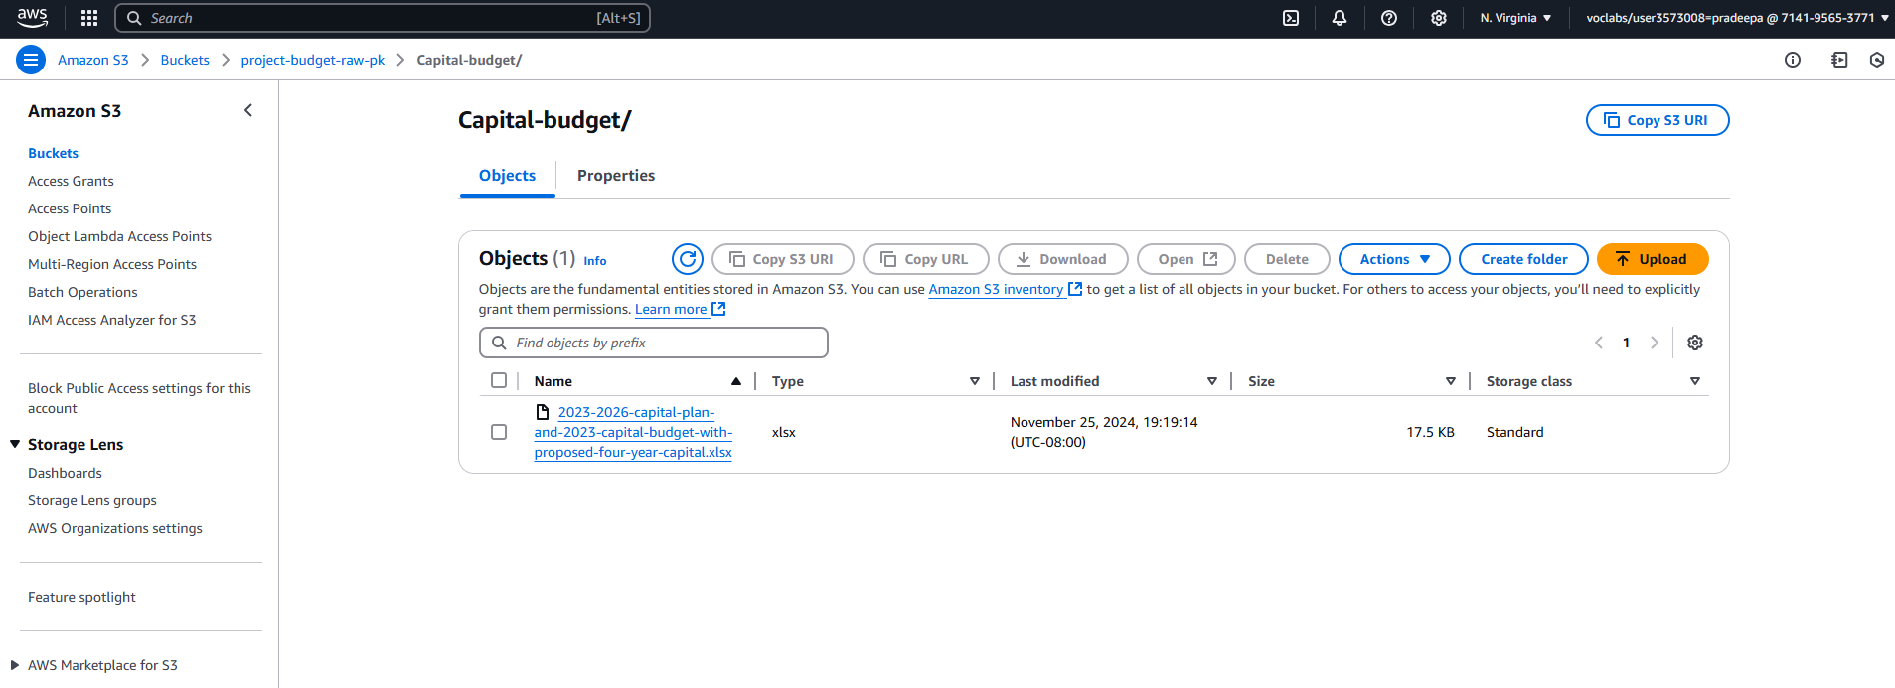

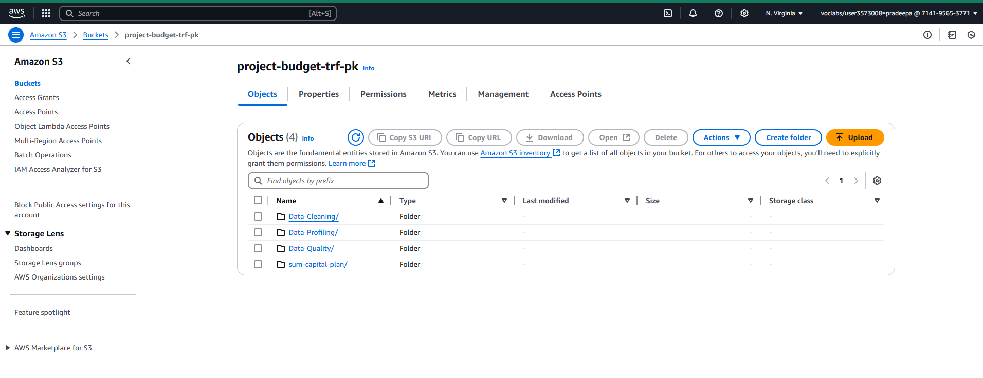

## Methodology:

1. Data Collection and Preparation:
   * Load budget data into AWS S3 for centralized access.
   * Use AWS DataBrew for data profiling and initial cleaning to remove duplicates, handle missing values, and correct data types.
2. Descriptive Statistics:
   * Summarize total and average costs per category.
   * Analyze year-wise allocation trends and major funding sources.
3. Data Visualization:
   * Create Bar Charts: Show year-wise changes in funding across project categories.
   * Pie Charts: Display the proportion of funding from different sources.
   * Heatmaps: Illustrate regional differences in budget distribution.
4. Customer Segmentation:
   * Segment customers based on their purchasing behavior (e.g., high-frequency vs. low-frequency buyers).
   * Analyze the purchasing patterns of different segments.
5. Insights and Findings:
   * Summarize the insights derived from the analysis, highlighting:
     + Peak shopping periods (e.g., holidays, weekends)
     + Trends in product category sales over time
     + Preferences in payment methods across customer segments
6. Recommendations:
   * Provide actionable recommendations based on the findings to inform inventory management, targeted marketing campaigns, and promotional strategies.

## Tools and Technologies:

* Python (Pandas, Matplotlib, Seaborn) or Excel for data analysis
* Data visualization tools (Tableau or Power BI) for creating dashboards

## Deliverables:

* A detailed report summarizing the methods, findings, and recommendations.
* Visualizations and dashboards to present key insights clearly.
* A presentation for stakeholders to communicate important findings and suggestions for future action.

This descriptive analysis project aims to provide a comprehensive understanding of customer purchase behaviors, enabling XYZ Retail to optimize its operations and enhance customer satisfaction.

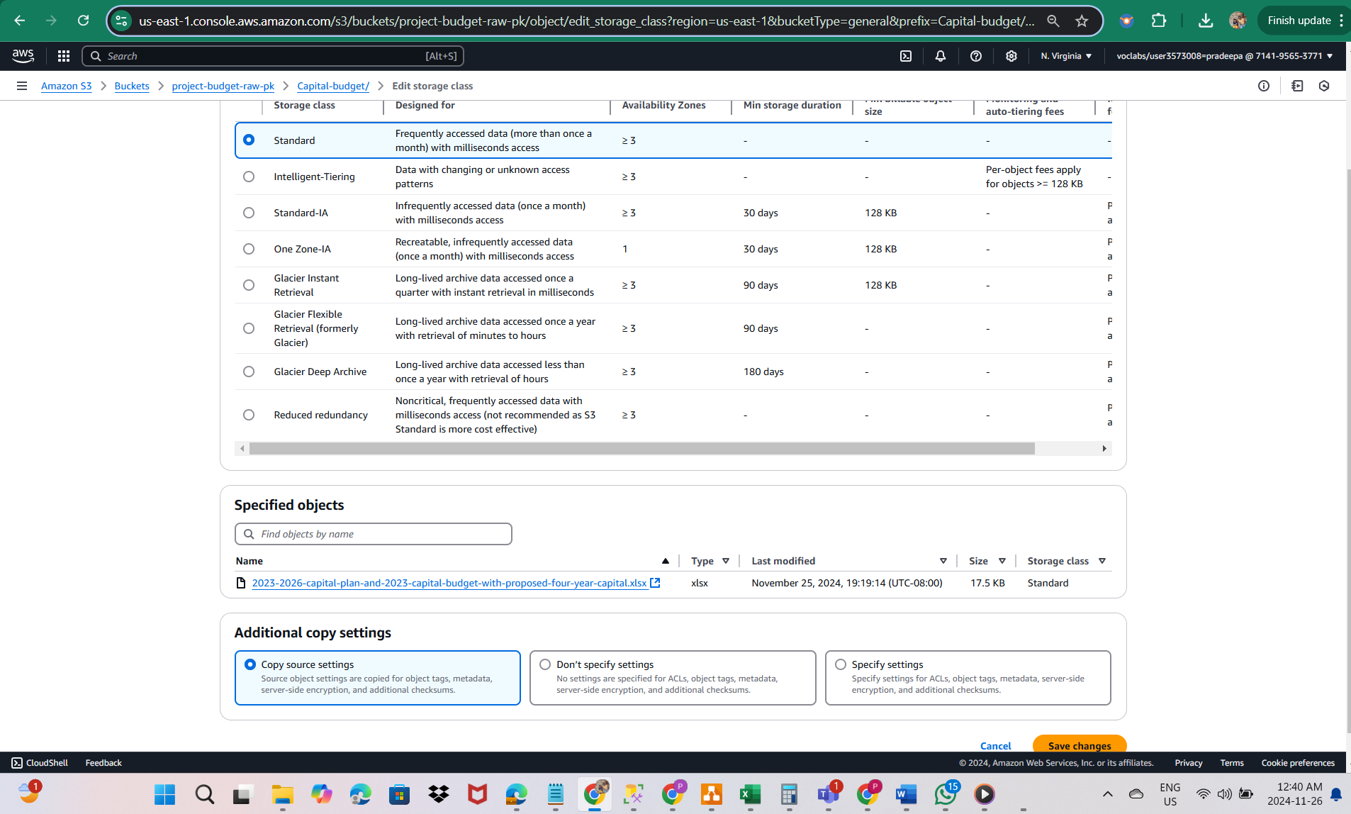

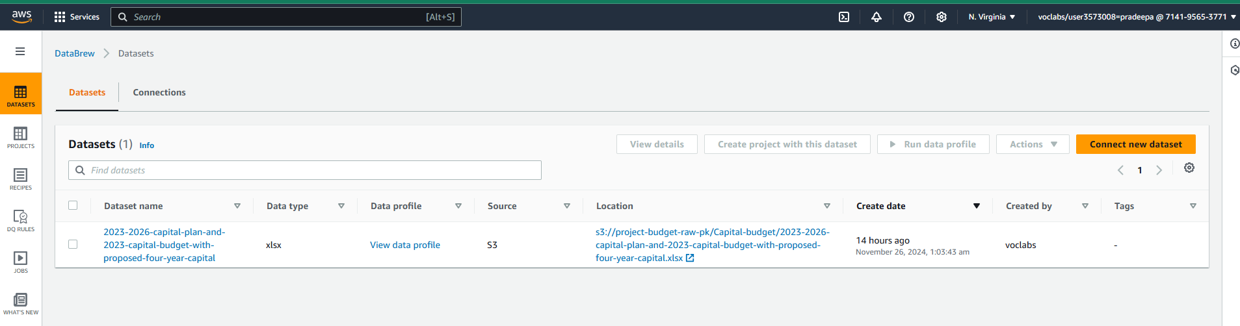

## Conclusion

This analysis enabled the City of Vancouver to understand critical patterns in its budget allocations. Using AWS services for storage, profiling, and processing ensured a streamlined and secure approach, while advanced visualization tools made the insights actionable for stakeholders. This project highlights the potential for data-driven decisions to enhance urban planning and resource management.

# Diagnostic Analysis

### Project Description: Diagnostic Analysis of Budget Allocation Changes in the City of Vancouver

Project Title: Investigating the Causes of Budget Variations in Vancouver’s Capital Plan

Objective: The primary goal of this project is to conduct a diagnostic analysis to identify the underlying causes of variations in budget allocations across different regions and categories in the City of Vancouver’s 2023–2026 Capital Plan and 2023 Capital Budget. By analyzing diverse datasets, we aim to uncover factors influencing these variations and provide actionable insights to inform more effective financial strategies.

Background: Over recent budget cycles, the City of Vancouver has observed notable shifts in capital allocations, raising concerns about alignment with urban priorities such as housing, infrastructure, and sustainability. Management seeks a thorough understanding of the drivers behind these changes to ensure the budget reflects the city’s strategic goals.

Dataset: The analysis leverages multiple datasets, including:

Budget Data: Yearly allocations across categories such as housing, transportation, and parks.

Demographic Data: Regional population density, growth trends, and socio-economic profiles.

Impact Data: Outcomes of previously funded projects, such as usage rates or community benefits.

Market and Economic Data: Regional economic indicators and trends affecting funding decisions.

## Methodology:

1. Data Collection and Preparation:
   * Consolidate datasets from various sources, including Vancouver's Open Data Portal and external economic reports.
   * Clean and normalize data to ensure consistency for analysis.
2. Trend Analysis:
   * Perform year-over-year comparisons of budget allocations across regions and categories.
   * Identify key areas with significant increases or decreases in funding.
3. Correlation Analysis:
   * Assess relationships between budget variations and external factors such as population growth, project outcomes, and economic conditions.
   * Apply statistical methods (e.g., regression analysis) to measure the influence of these variables on budget changes.
4. Root Cause Analysis:
   * Engage city officials and stakeholders through interviews to gather qualitative insights on shifts in priorities.
   * Use diagnostic tools like the "5 Whys" or Fishbone Diagram to systematically investigate underlying causes.
5. Segmentation Analysis:
   * Segment regions and project categories based on funding levels and demographic factors.
   * Analyze how resource allocation impacts different community groups.
6. Synthesis of Findings:
   * Combine quantitative and qualitative insights to identify the primary drivers of budget variations.
   * Highlight patterns and inconsistencies in allocation practices.

## Tools and Technologies:

* SQL for data extraction and preprocessing.
* AWS Services:
* AWS DataBrew for data profiling and cleaning.
* AWS Glue for ETL pipeline execution.

## Deliverables:

* A comprehensive diagnostic report that outlines the analysis process, findings, and confirmed root causes of the sales decline.
* Visualizations and dashboards summarizing key metrics and trends.
* Actionable recommendations for management, focusing on strategies to address identified issues and improve sales performance.
* maintain a clear separation between raw and transformed datasets.

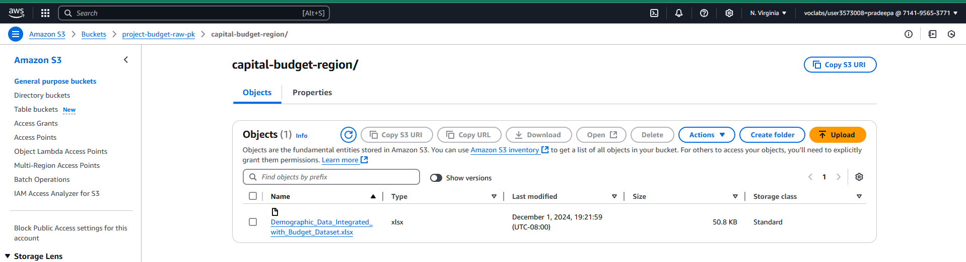

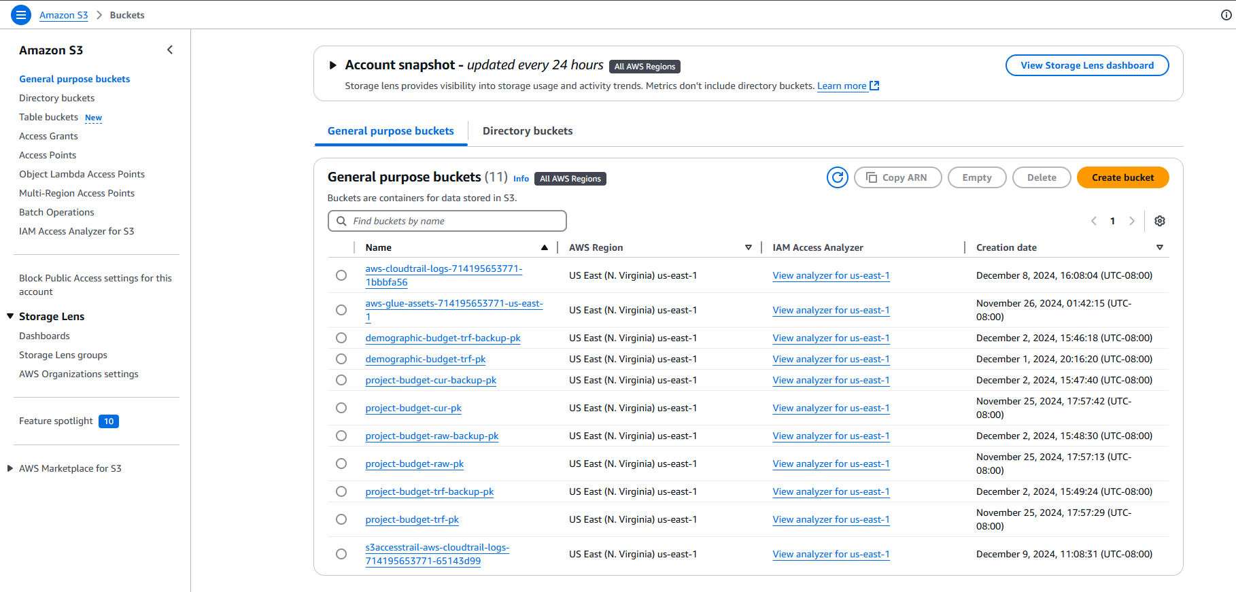

2. I have created a project in AWS Data Brew, "Demographic-Capital-budget-proj-pk," for data profiling and data cleaning jobs to understand the dataset, get an overview, and clean the dataset for transformation. Post that I have worked on data enriching in AWS glue through visual ETL for data enriching.

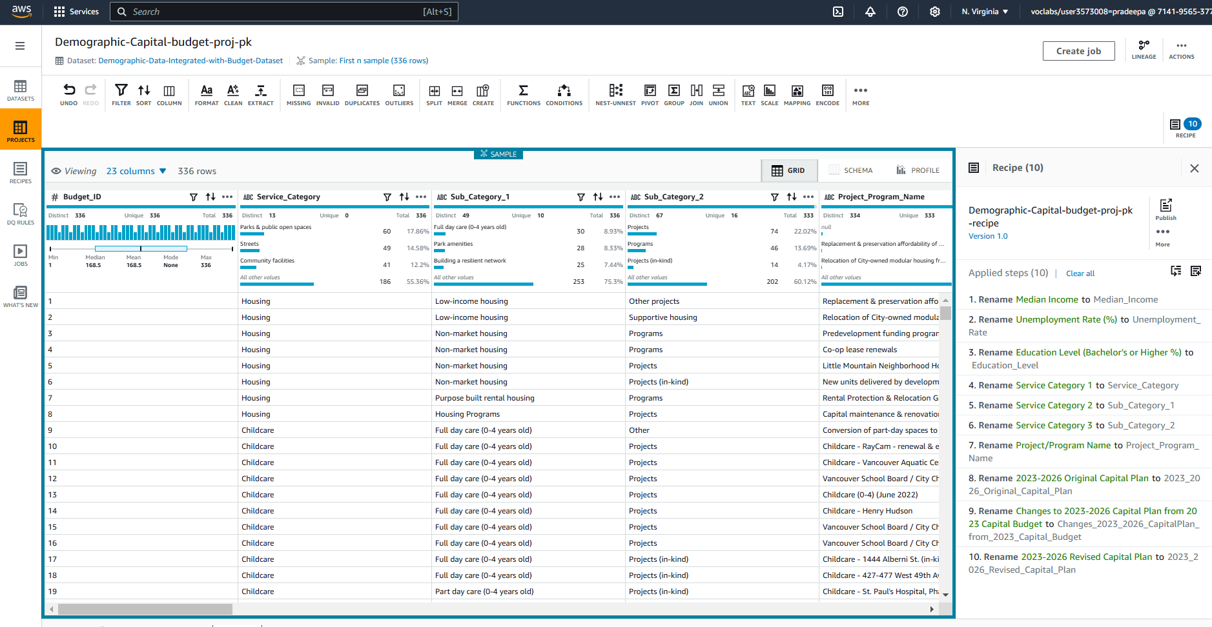

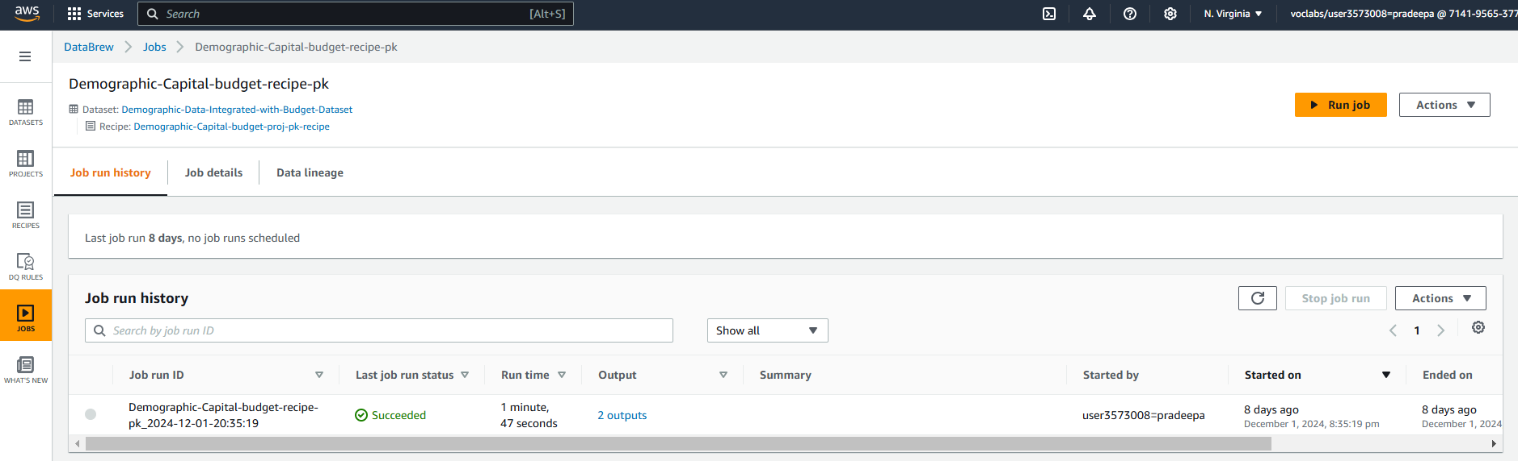

3. I have used a crawler service and created “Final_Results” and “capital-budget-region” crawler service. Added the tables from transformed data to create the data catalog tables, which have been used as the source for my data enriching in visual ETL.

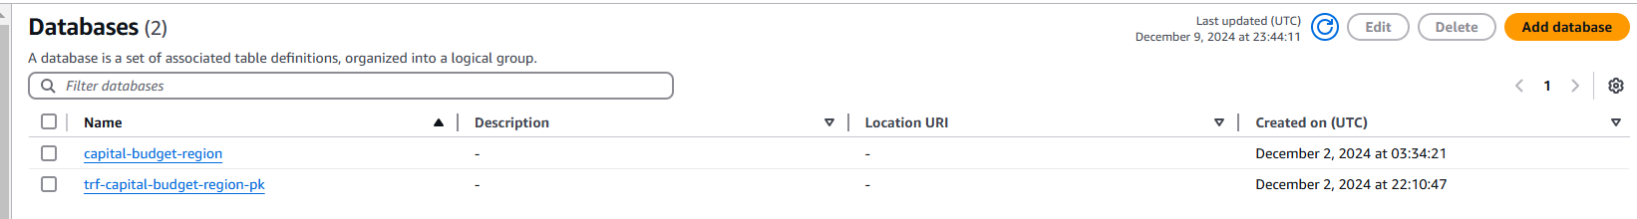

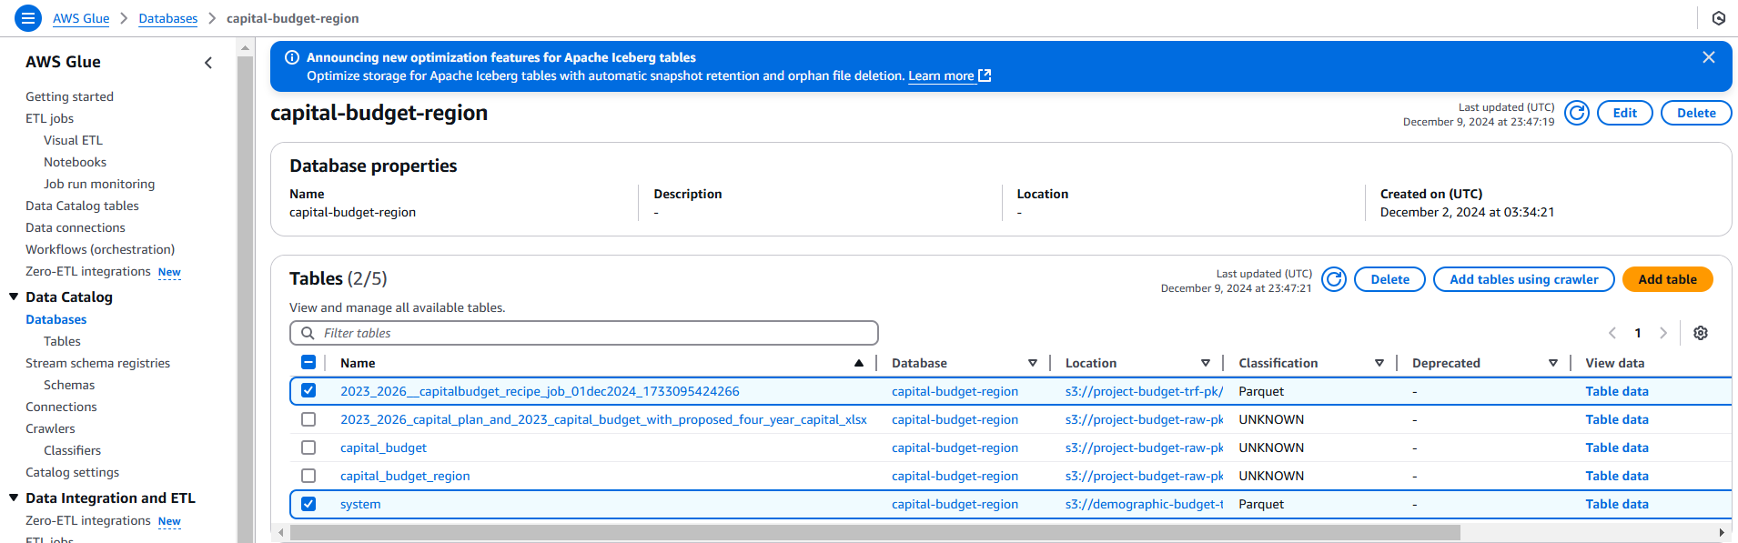

I designed a visual ETL (Extract, Transform, Load) pipeline “Capital-budget-pk” using AWS Glue to perform data processing:

Source Data Selection: The transformed data stored in data catalog tables was used as the source for the pipeline.

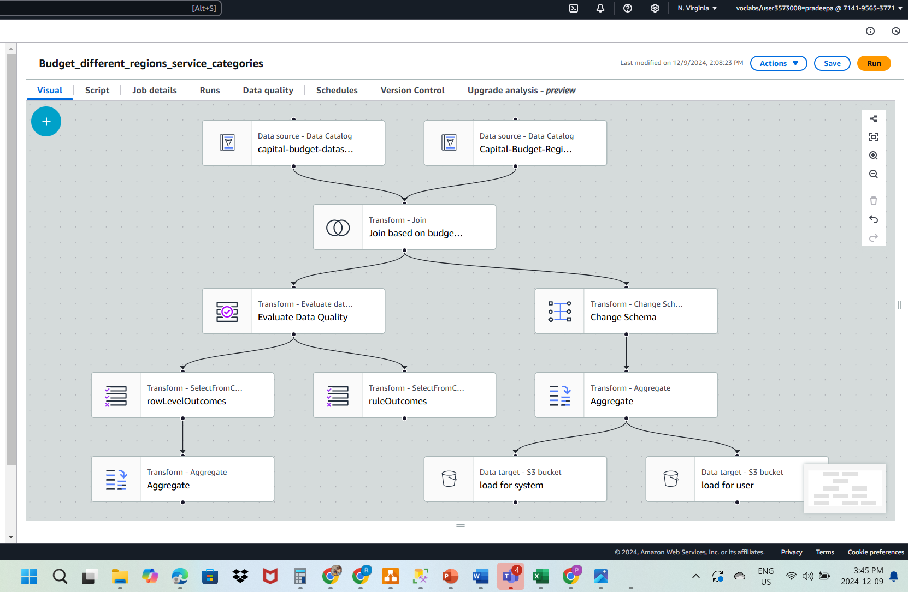

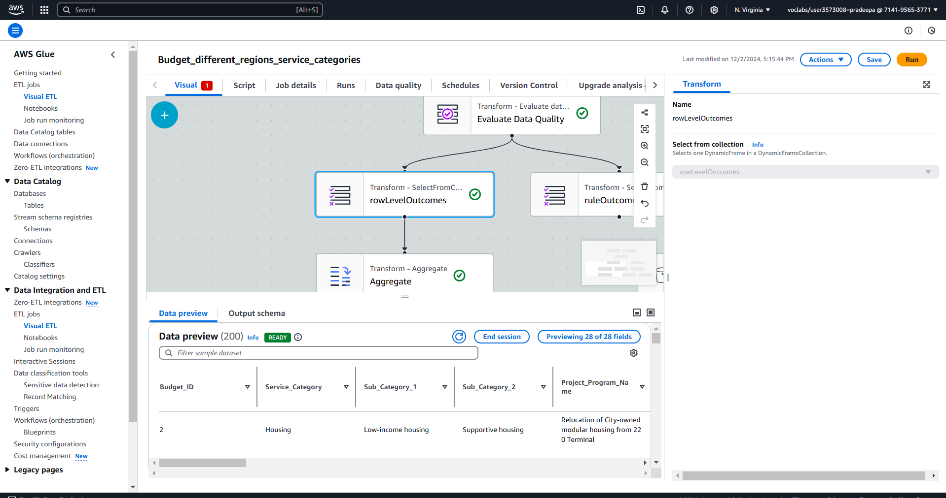

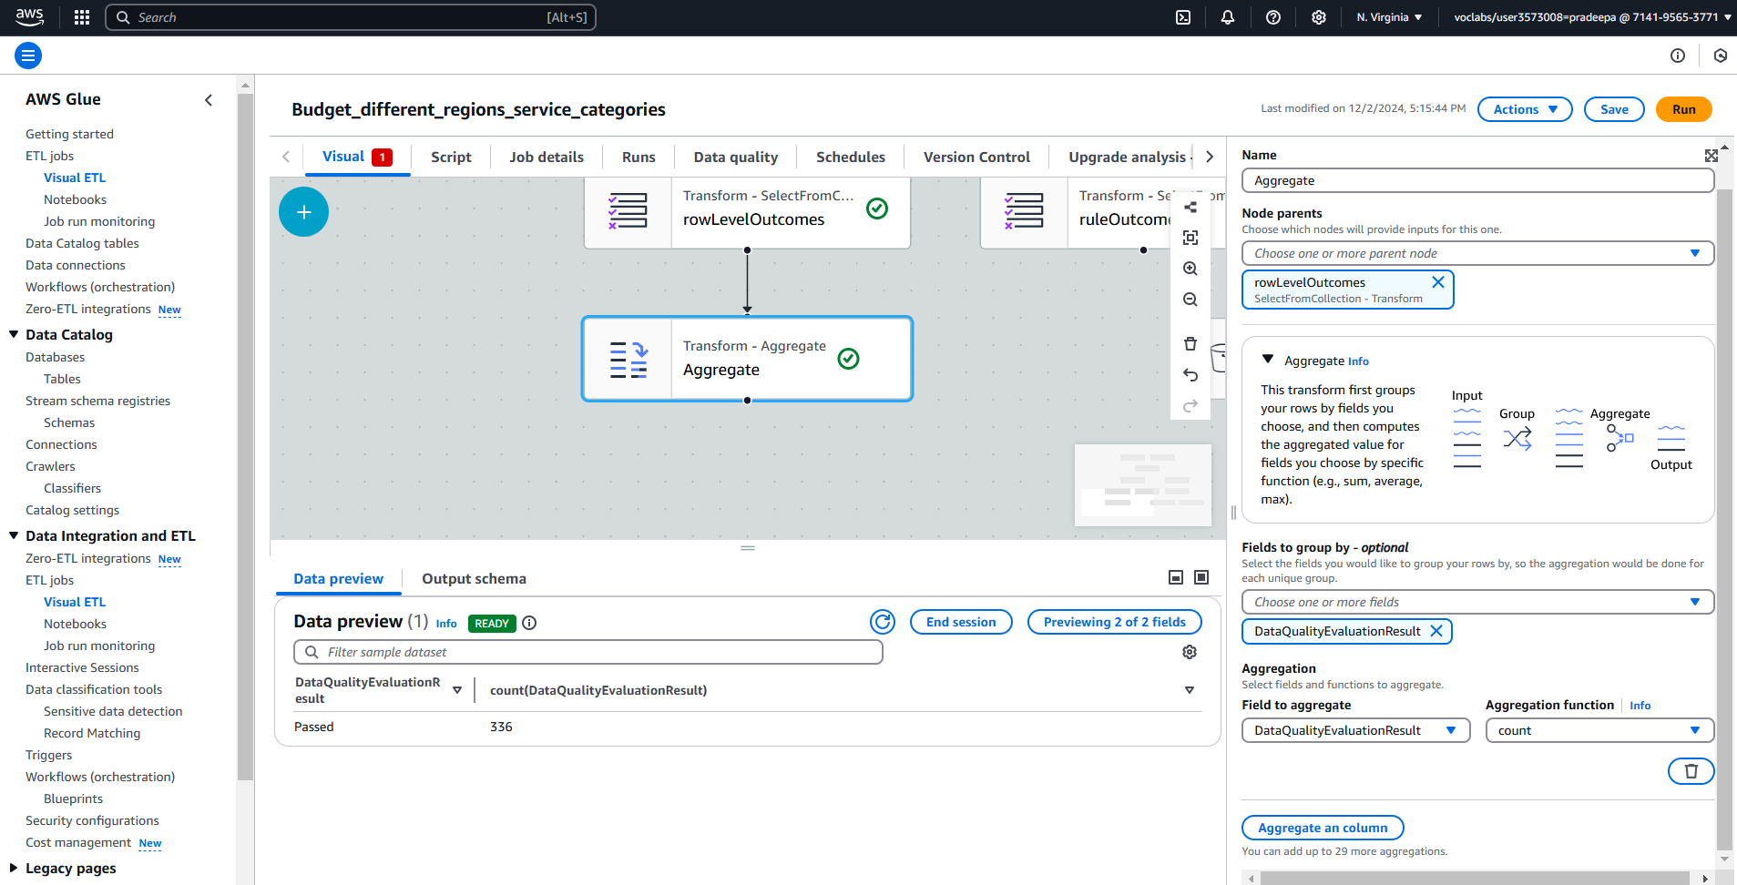

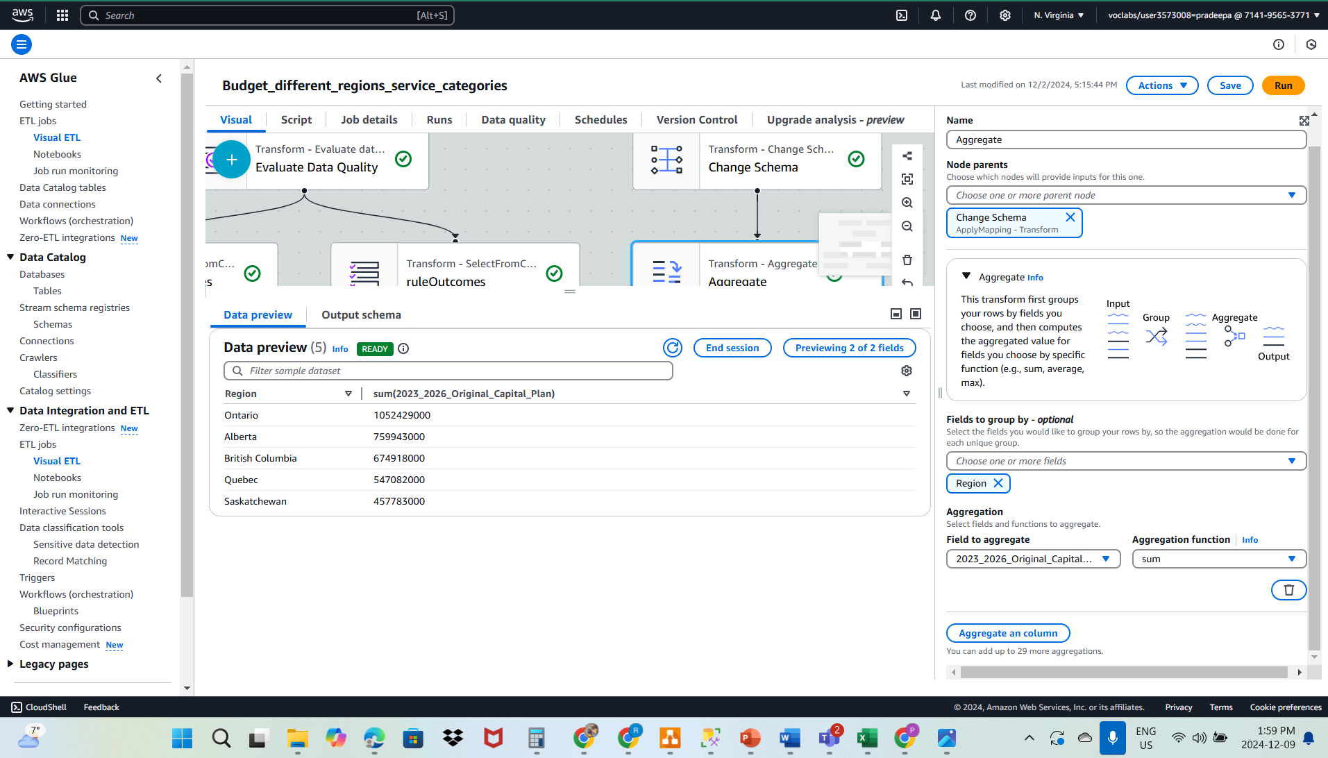

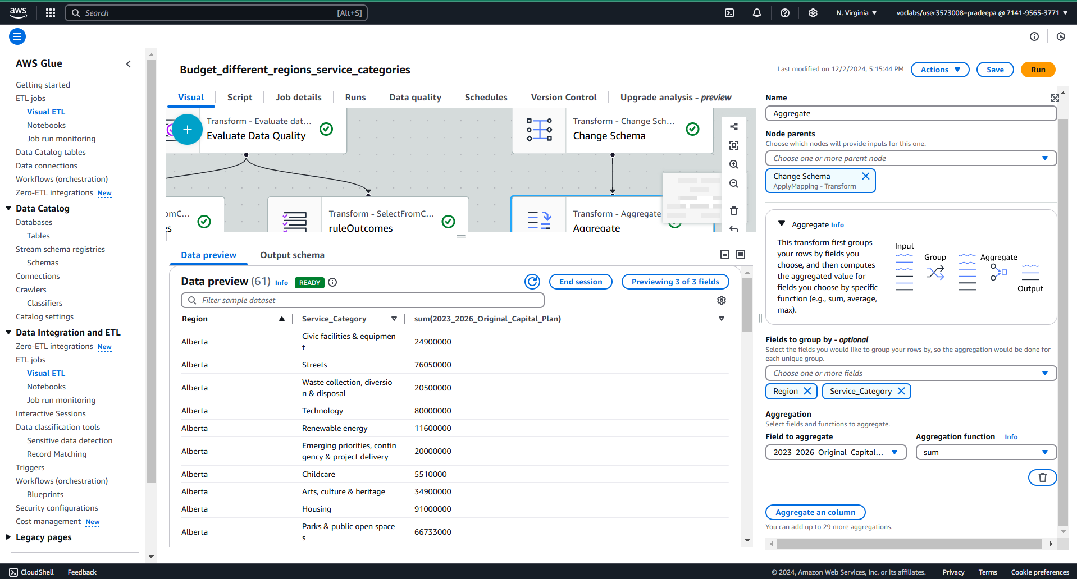

Amazon Athena: After completing the visual ETL execution, I queried the created data catalog outputs through Amazon Athena. Attached is the snippet for reference.

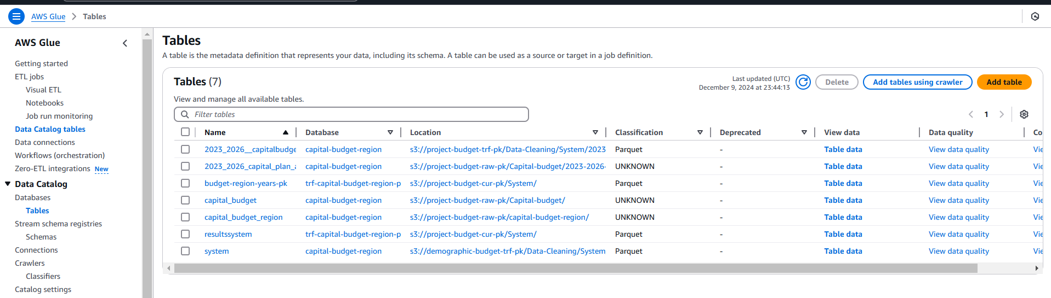

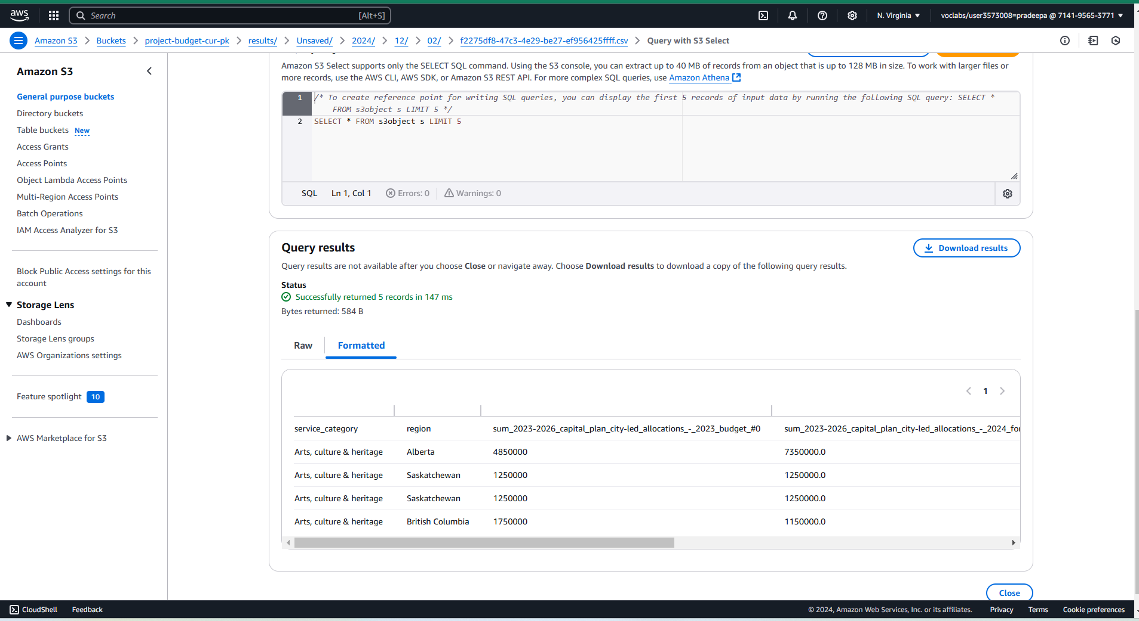

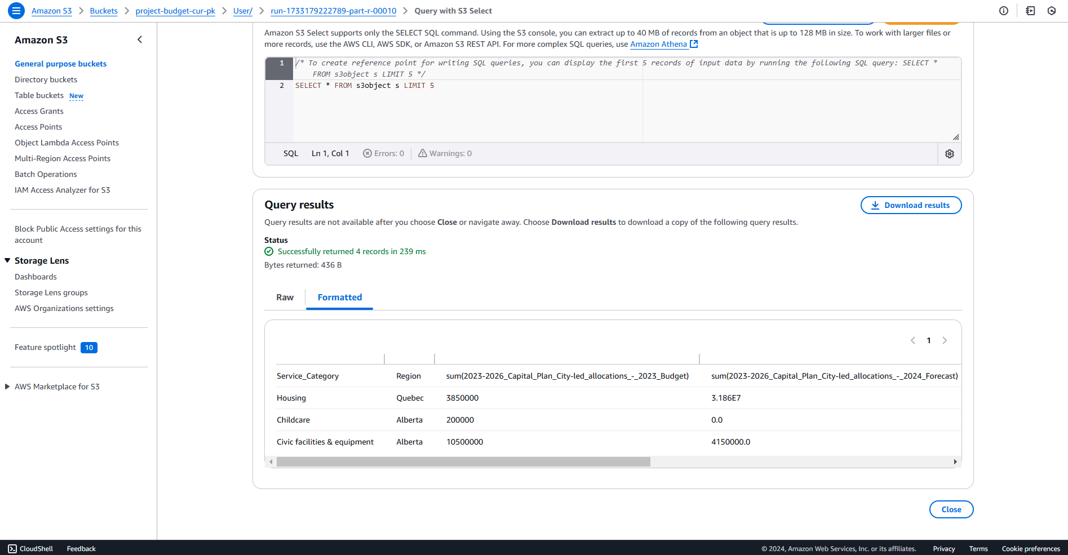

Amazon Athena: After running the data-enriching step and answering the diagnostic question by querying the output. I have placed some of the sample SQL outputs for reference.

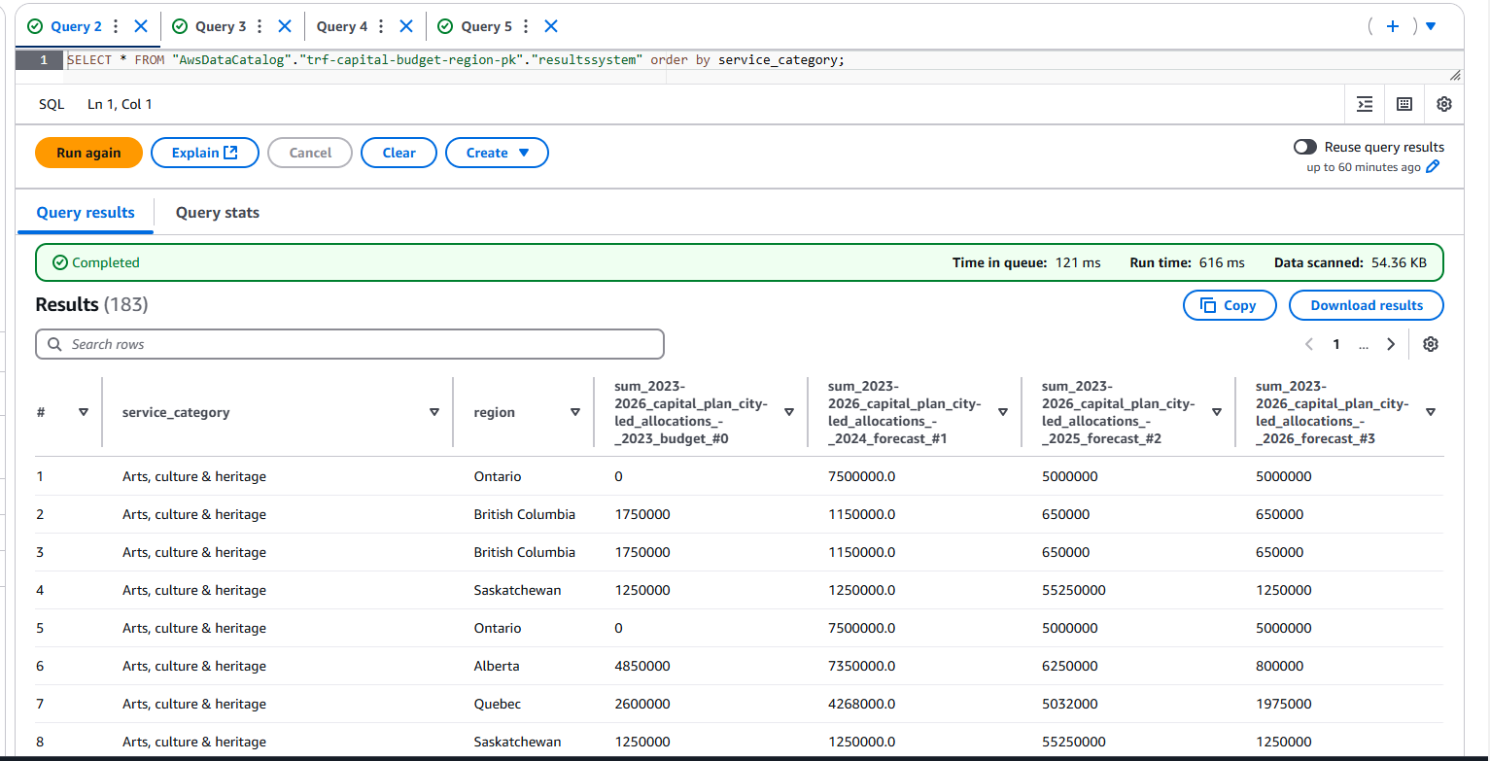

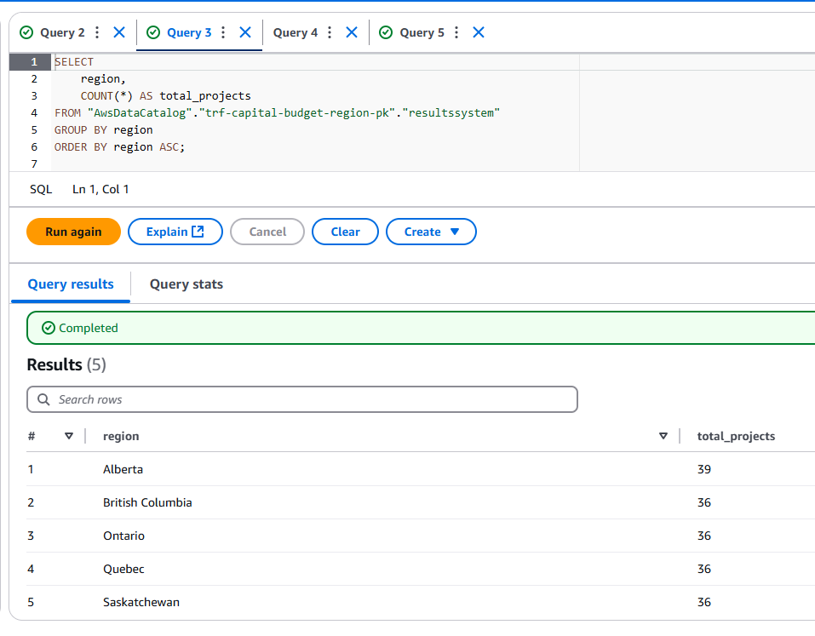

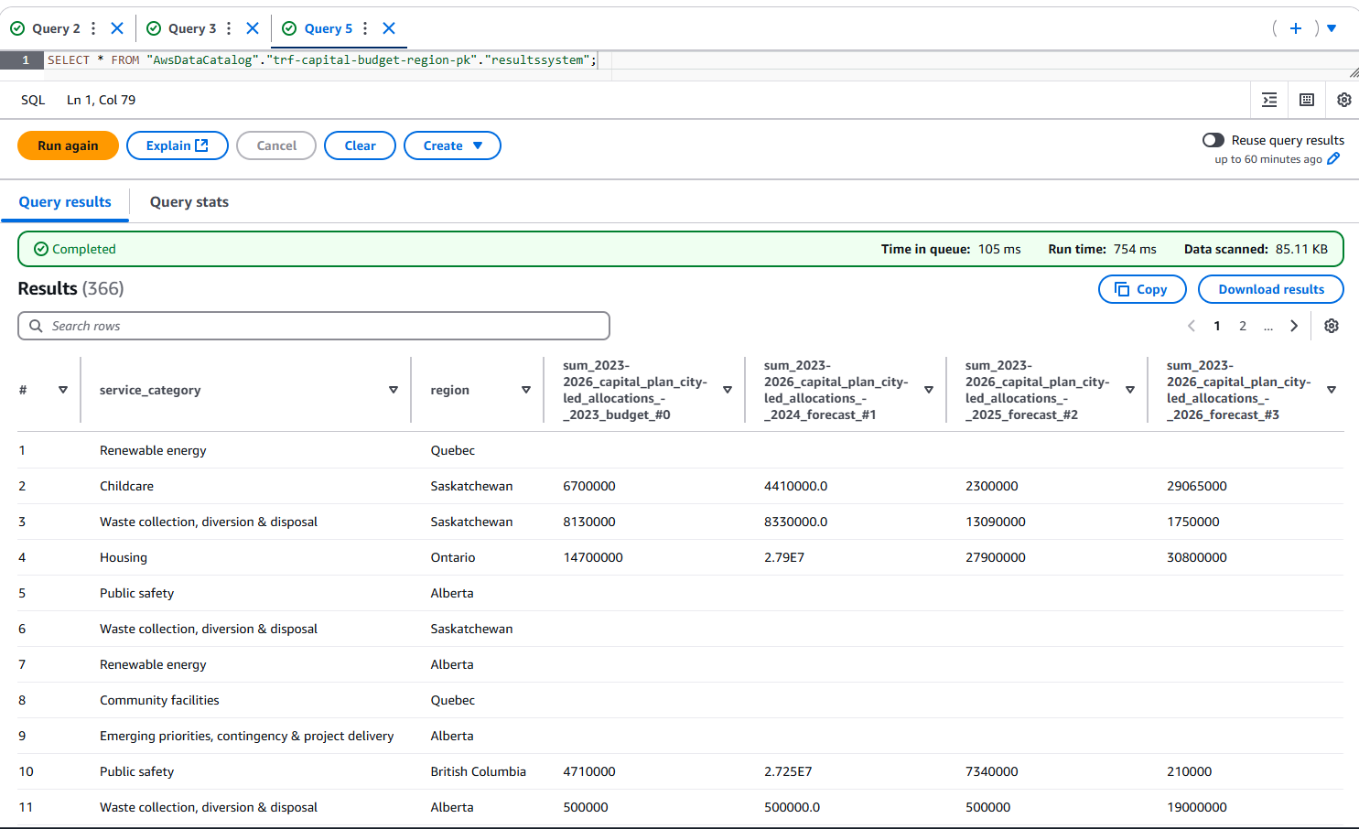

Step 6: Data Protection

I have used key management services (KMS) to include data protection for my data analytics project.

vc-budget-key-pk is the name of the KMS key. LabRole has been added as both key users and key administrators to manage the key. As well as added (vc-budget-key-pk) key for all the buckets for data protection.

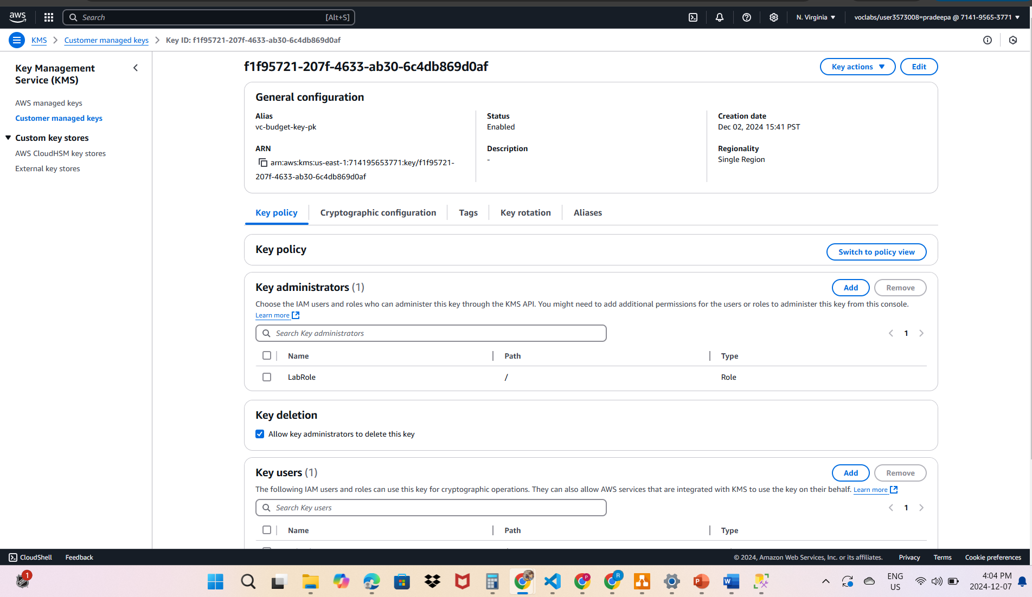

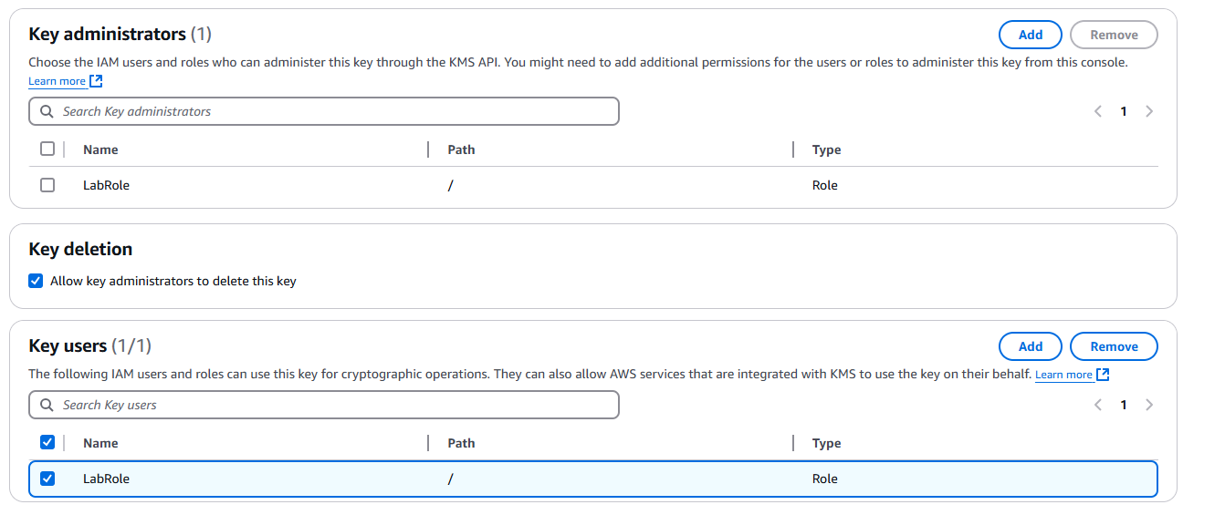

Added the key for S3 buckets to enable Server-side encryption with AWS Key Management Service keys (SSE-KMS)



As well as have created replication rules to ensure data durability and availability in case of accidental deletion, corruption, or regional outages. By replicating data across AWS regions or buckets, you protect against single-region failures and ensure disaster recovery. I have setup the same region replication to replicate data from a primary S3 bucket to a backup bucket

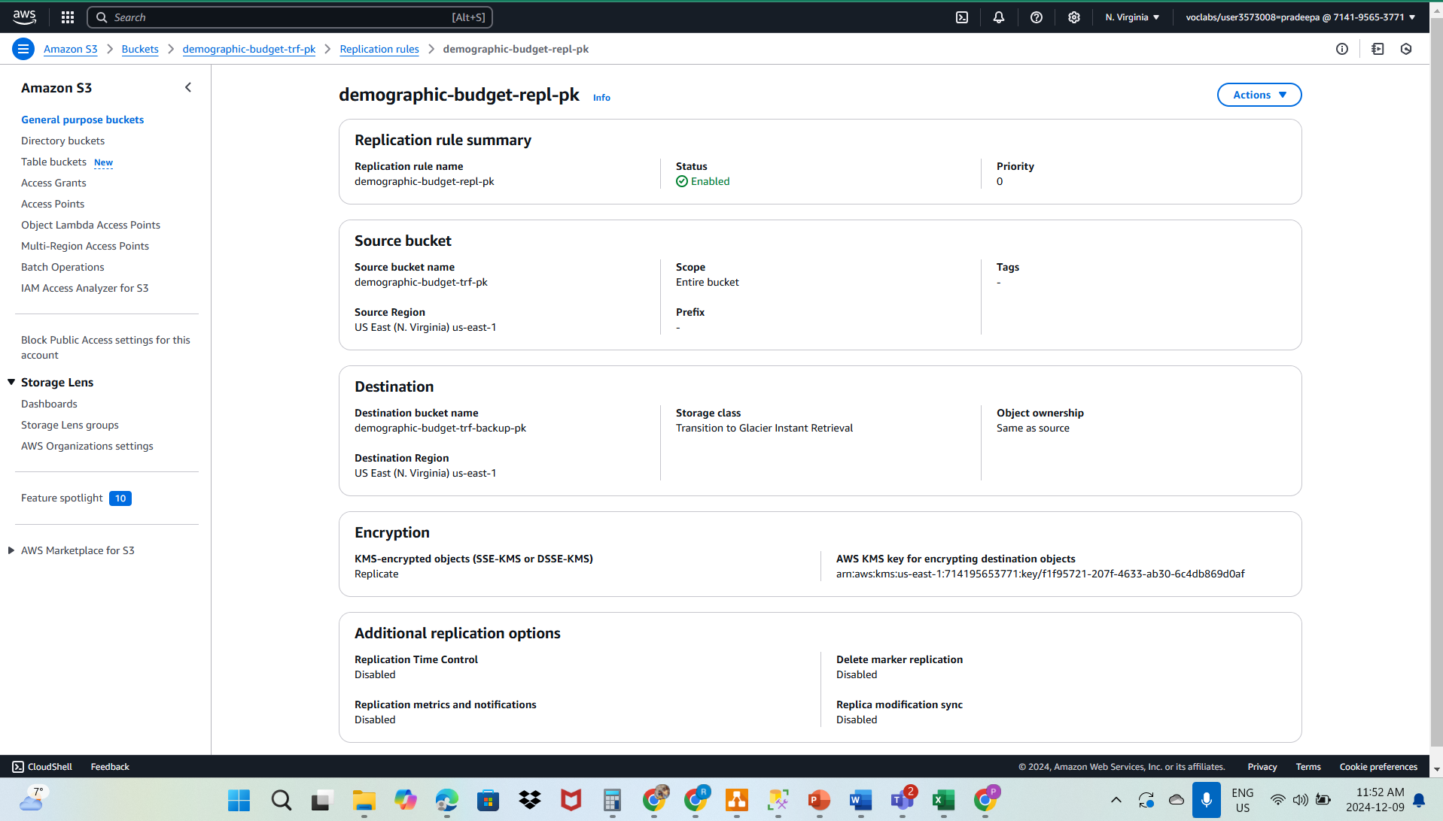

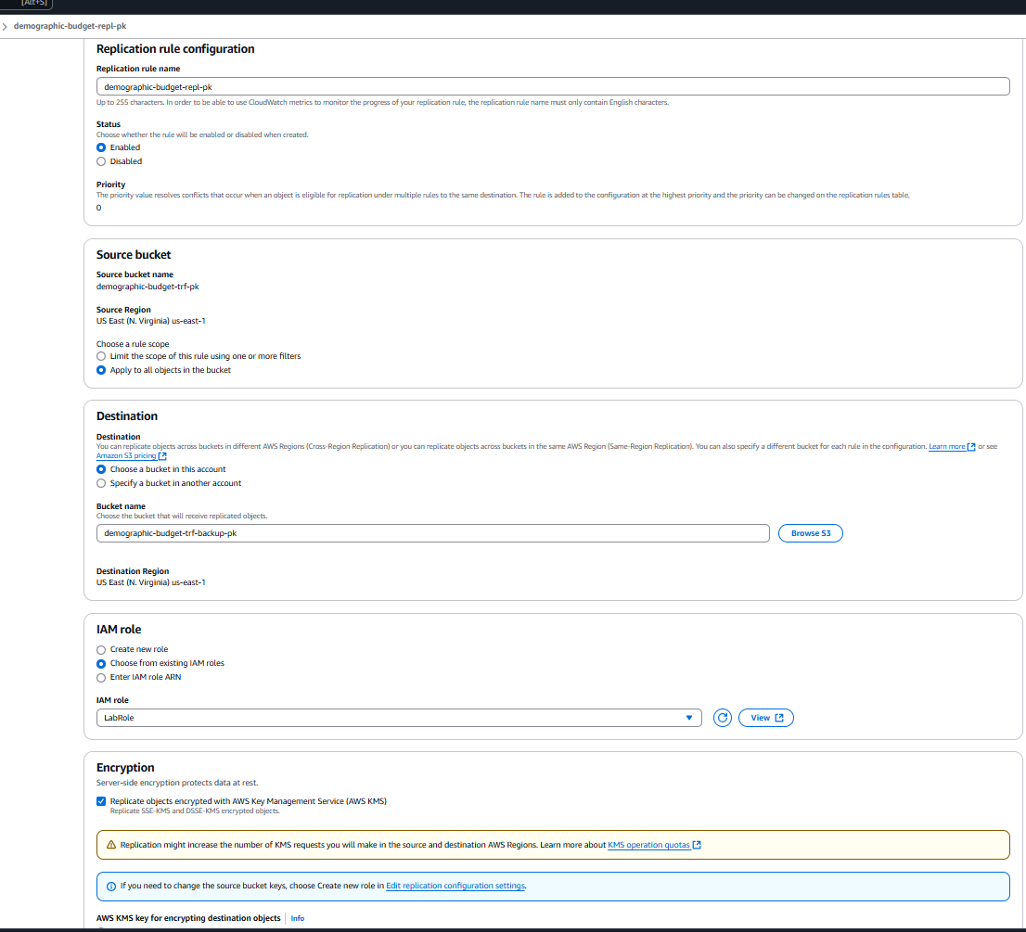

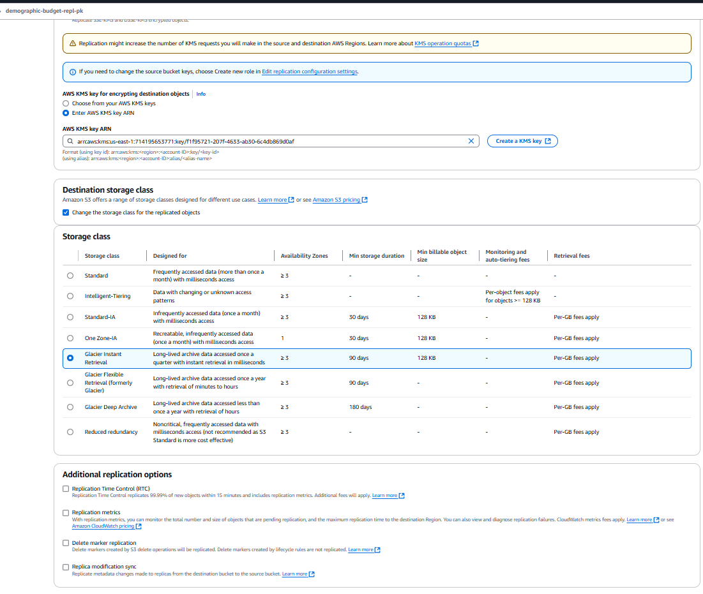

Step 7: Data Governance

**Amazon CloudTrail**:

Created “S3AccessTrail-DAP-pk” CloudTrail to track access and modifications to datasets.

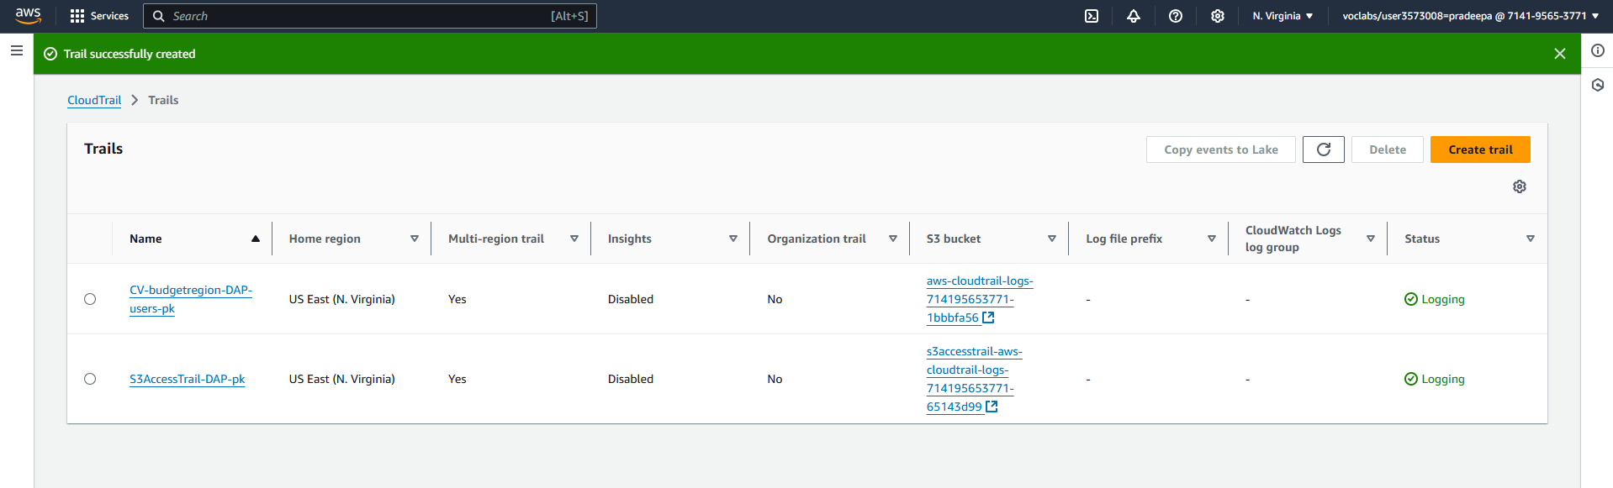

Implemented Lifecycle rules to enforce policies for data retention and archiving. Used lifecycle rules to retain data for a specified period based on governance policies. I have defined expiration rules to delete data no longer needed, ensuring compliance with data retention policies. Also, our domain is finance, these records are maintained in the S3 Standard storage class for 7 years and then archived in Glacier.

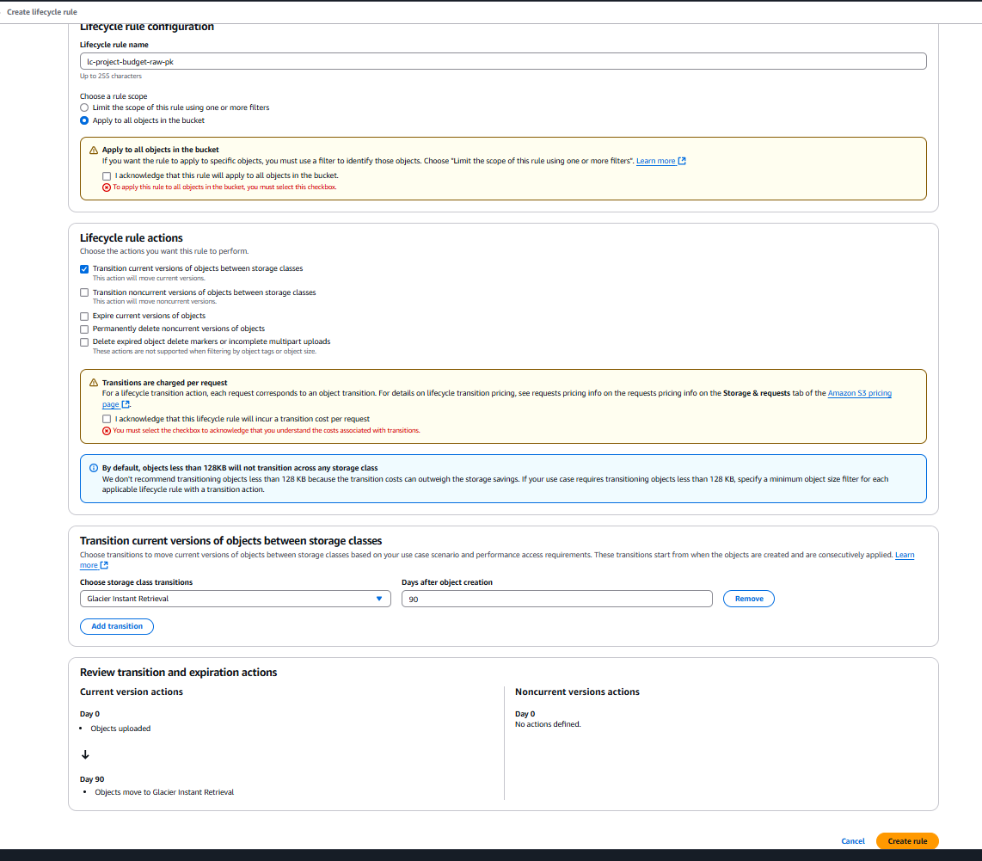

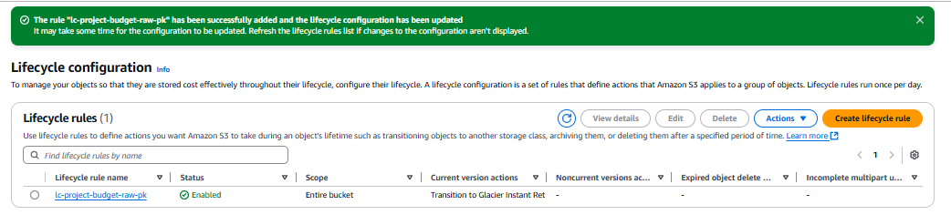

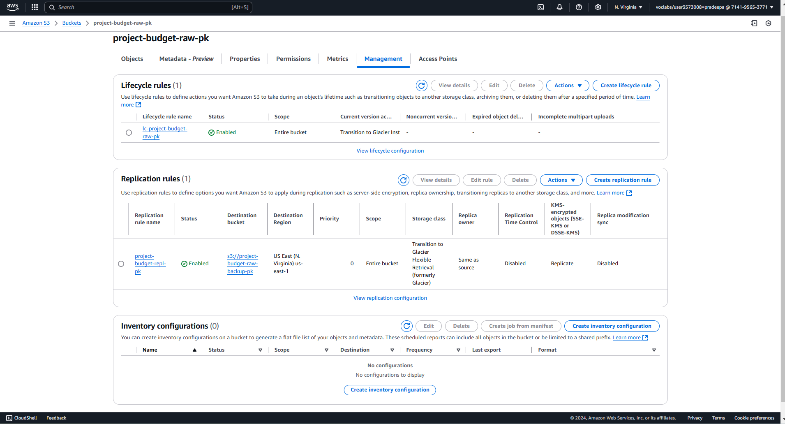

Step 8: Data Observability

I have successfully set up a monitoring and alerting system for the data processing infrastructure. A dashboard named budget-2023-26-DAP-Dash-pk was created in Amazon CloudWatch to track critical metrics for your S3 buckets and AWS Glue jobs. For the S3 buckets, I have enabled monitoring of the BucketSizeBytes metric for project-budget-raw-pk and demographic-budget-trf-pk, as well as the NumberOfObjects metric for demographic-budget-trf-pk. These metrics ensure keeping an eye on storage usage and the number of files in these buckets. Additionally, alerts have been configured to notify you when specific thresholds are crossed, such as when the number of objects in the curated bucket exceeds the expected count.

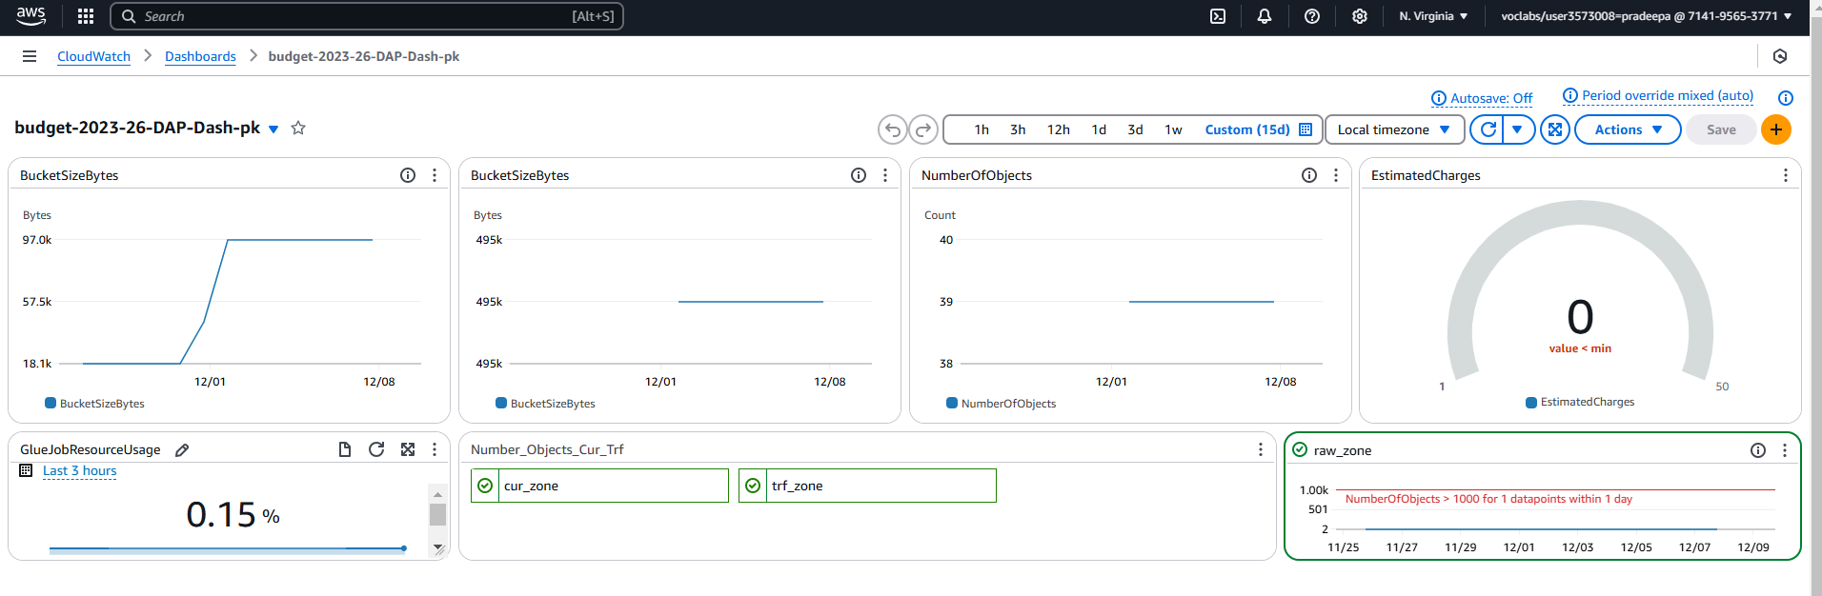

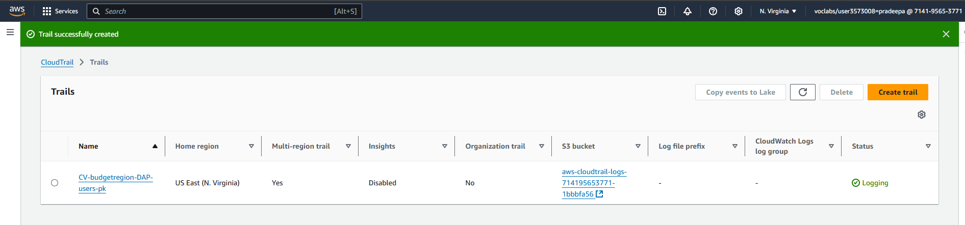

## Timeline:

* Project Duration: 6 weeks, divided into the following phases:
* Weeks 1–2: Data collection, profiling, and preparation.
* Weeks 3–4: Trend and correlation analysis.
* Weeks 5–6: Root cause identification, synthesis of findings, and stakeholder presentations.

This diagnostic analysis aims to provide a clear understanding of the factors influencing budget variations in the City of Vancouver, enabling management to make data-driven decisions that enhance urban planning and resource allocation efficiency.

# Data Wrangling

### Project Description: Data Wrangling for Budget Analysis at the City of Vancouver Project Title: Data Wrangling for Enhanced Budget and Funding Insights

Objective: The primary goal of this project is to perform comprehensive data wrangling on the City of Vancouver’s 2023–2026 Capital Plan and 2023 Capital Budget datasets. By cleaning, transforming, and consolidating data, the project aims to prepare a high-quality dataset that provides actionable insights for budget allocation and planning.

Background: The City of Vancouver's budgeting process involves multiple datasets, including funding sources, project costs, and allocations across years and categories. However, the raw data often contains missing values, inconsistencies, and formatting issues, making it challenging to derive meaningful insights. This project focuses on preparing clean, consistent data for subsequent analysis and reporting.

Dataset: The datasets used in the wrangling process include:

Capital Budget Data: Allocations for infrastructure, parks, housing, and transportation.

Funding Sources: Details of external and internal funding contributions.

Regional Allocations: Distribution of funds across different areas of Vancouver.

## Methodology:

1. Data Collection:
   * Load raw budget data into AWS S3 for centralized storage and access.
   * 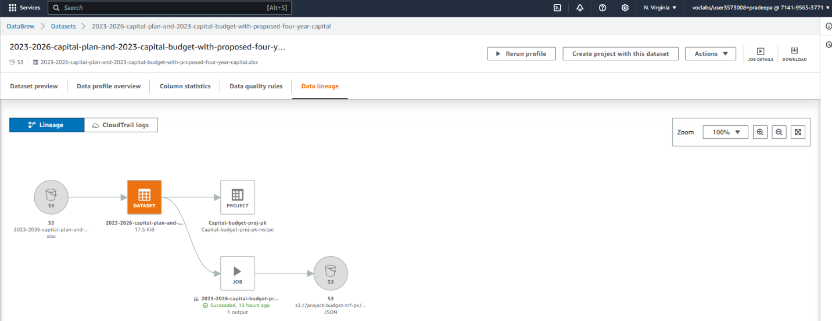Ensure all relevant datasets are available, including funding and regional data.

* 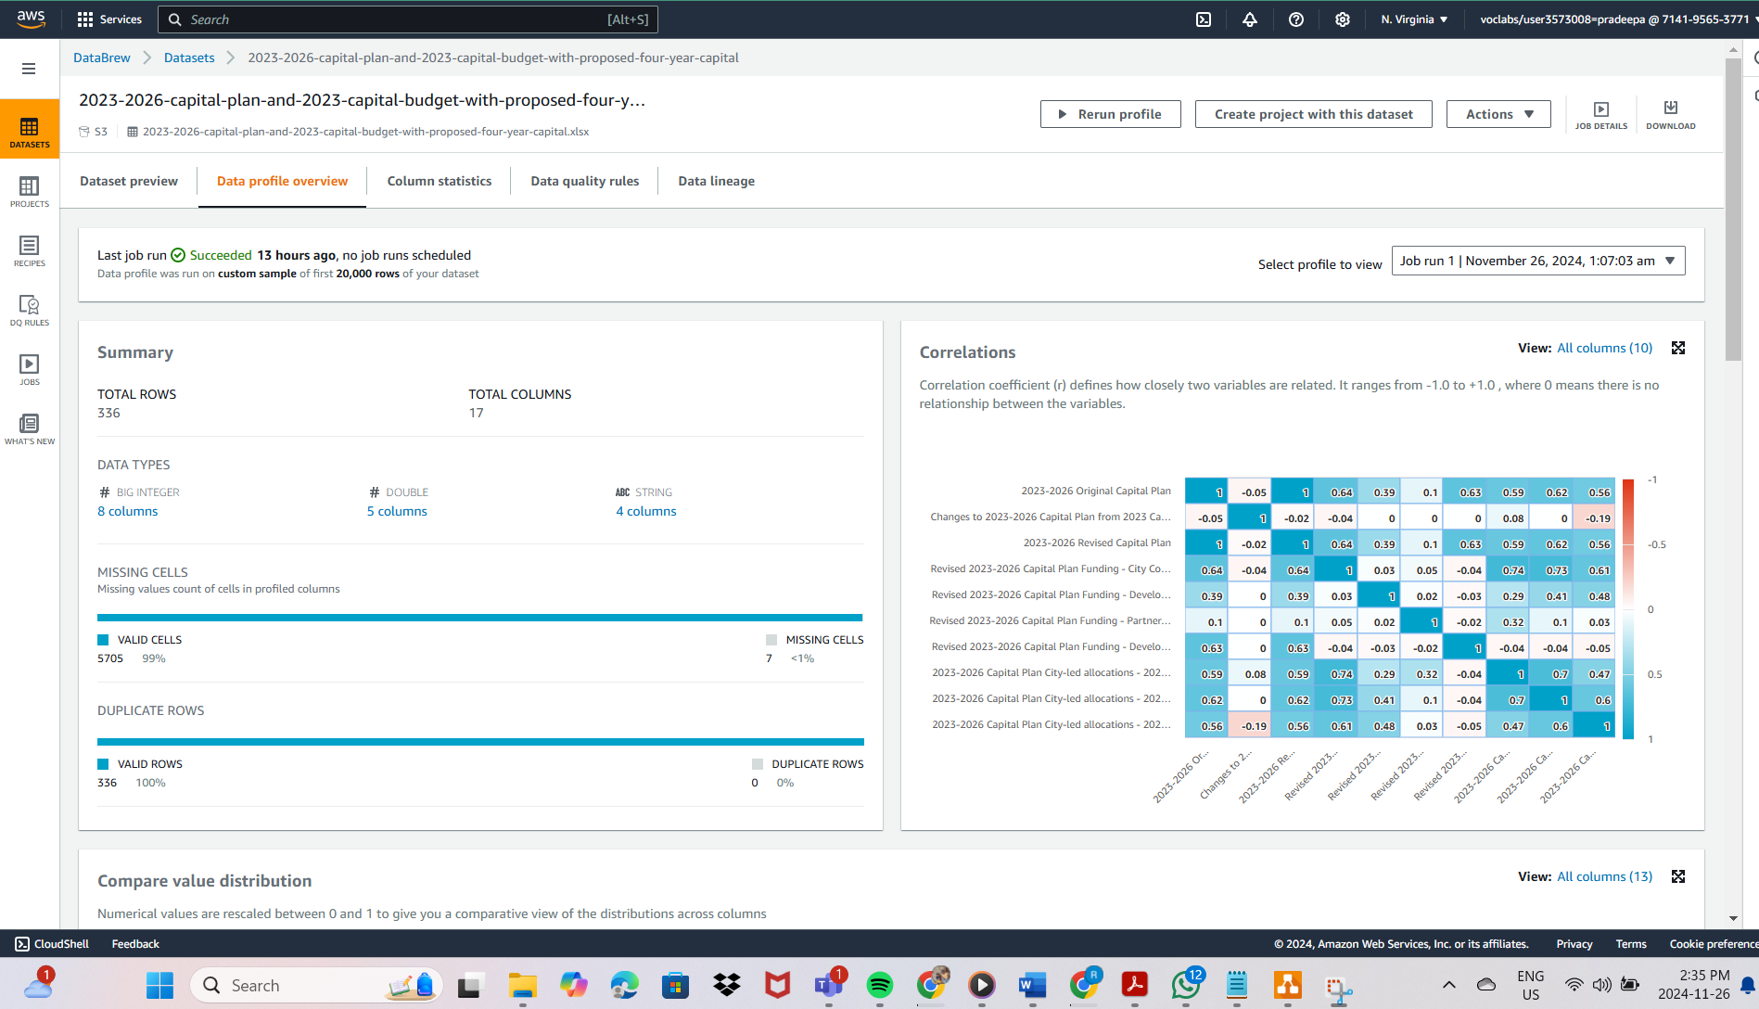
* This profiling step was important to understand the quality of the dataset and determine what cleaning steps are necessary.

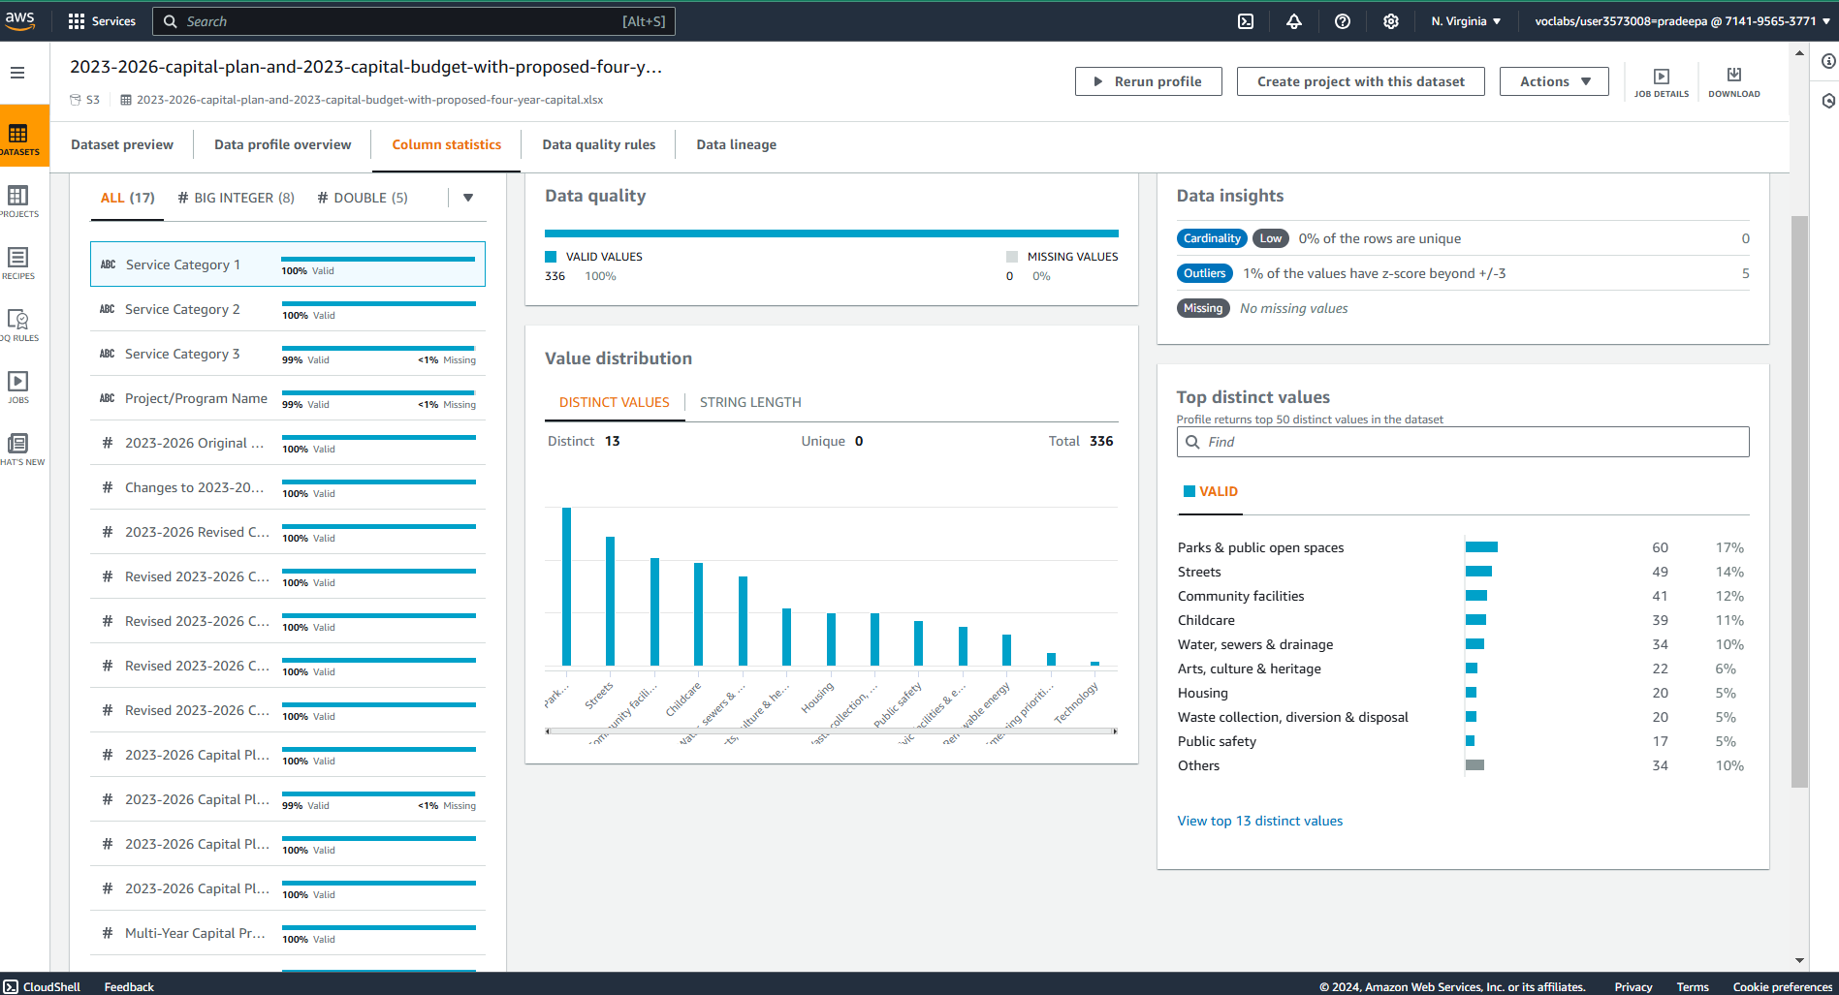

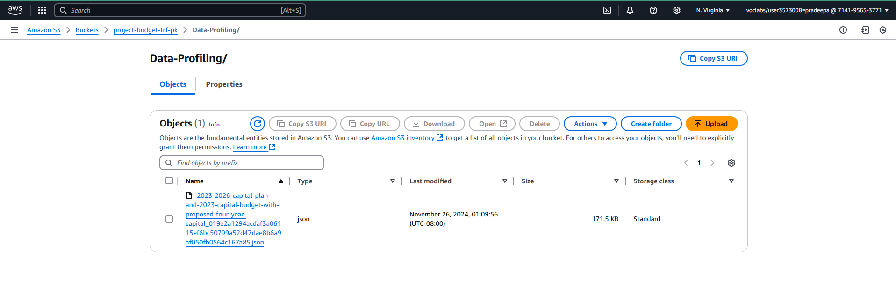

1. Data Assessment:
   * Use AWS DataBrew to profile the datasets, identifying missing values, duplicates, and inconsistencies.
   * Document the structure, types, and discrepancies in the raw data.
2. Data Cleaning:
   * Handle missing values through imputation or exclusion based on context.
   * Remove duplicate records and standardize column names and formats.
   * Normalize categorical variables (e.g., funding categories).

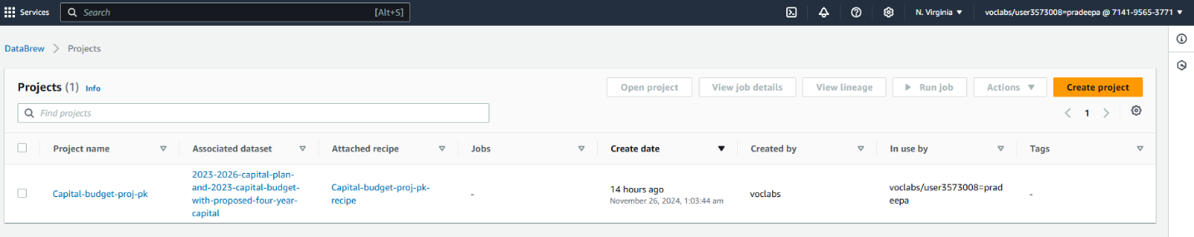

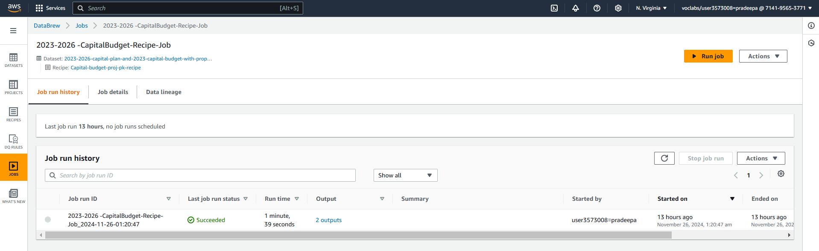

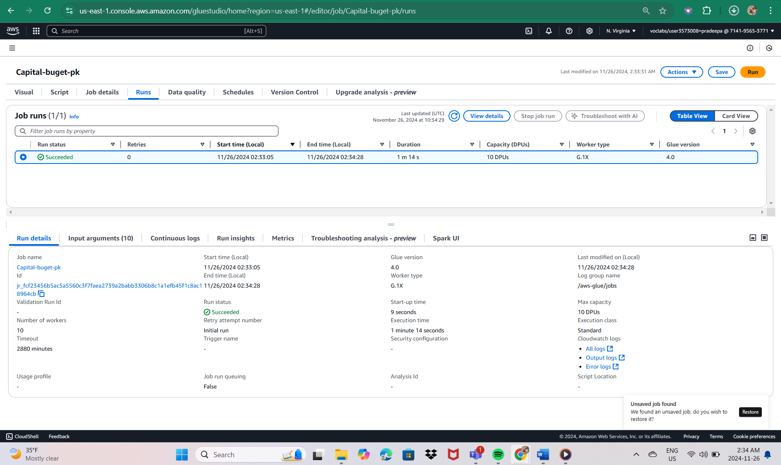

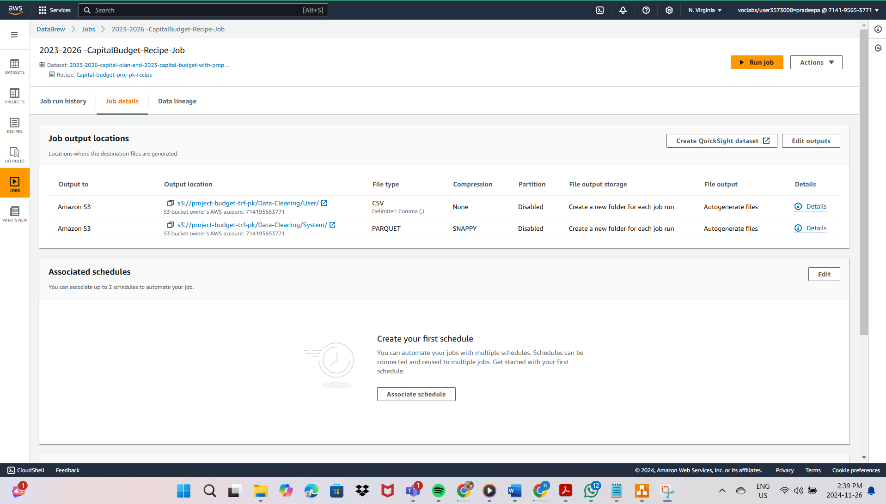

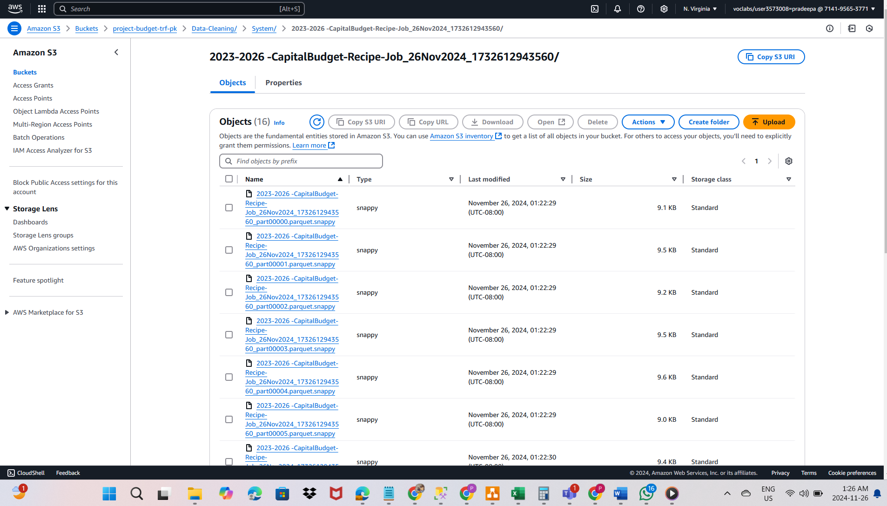

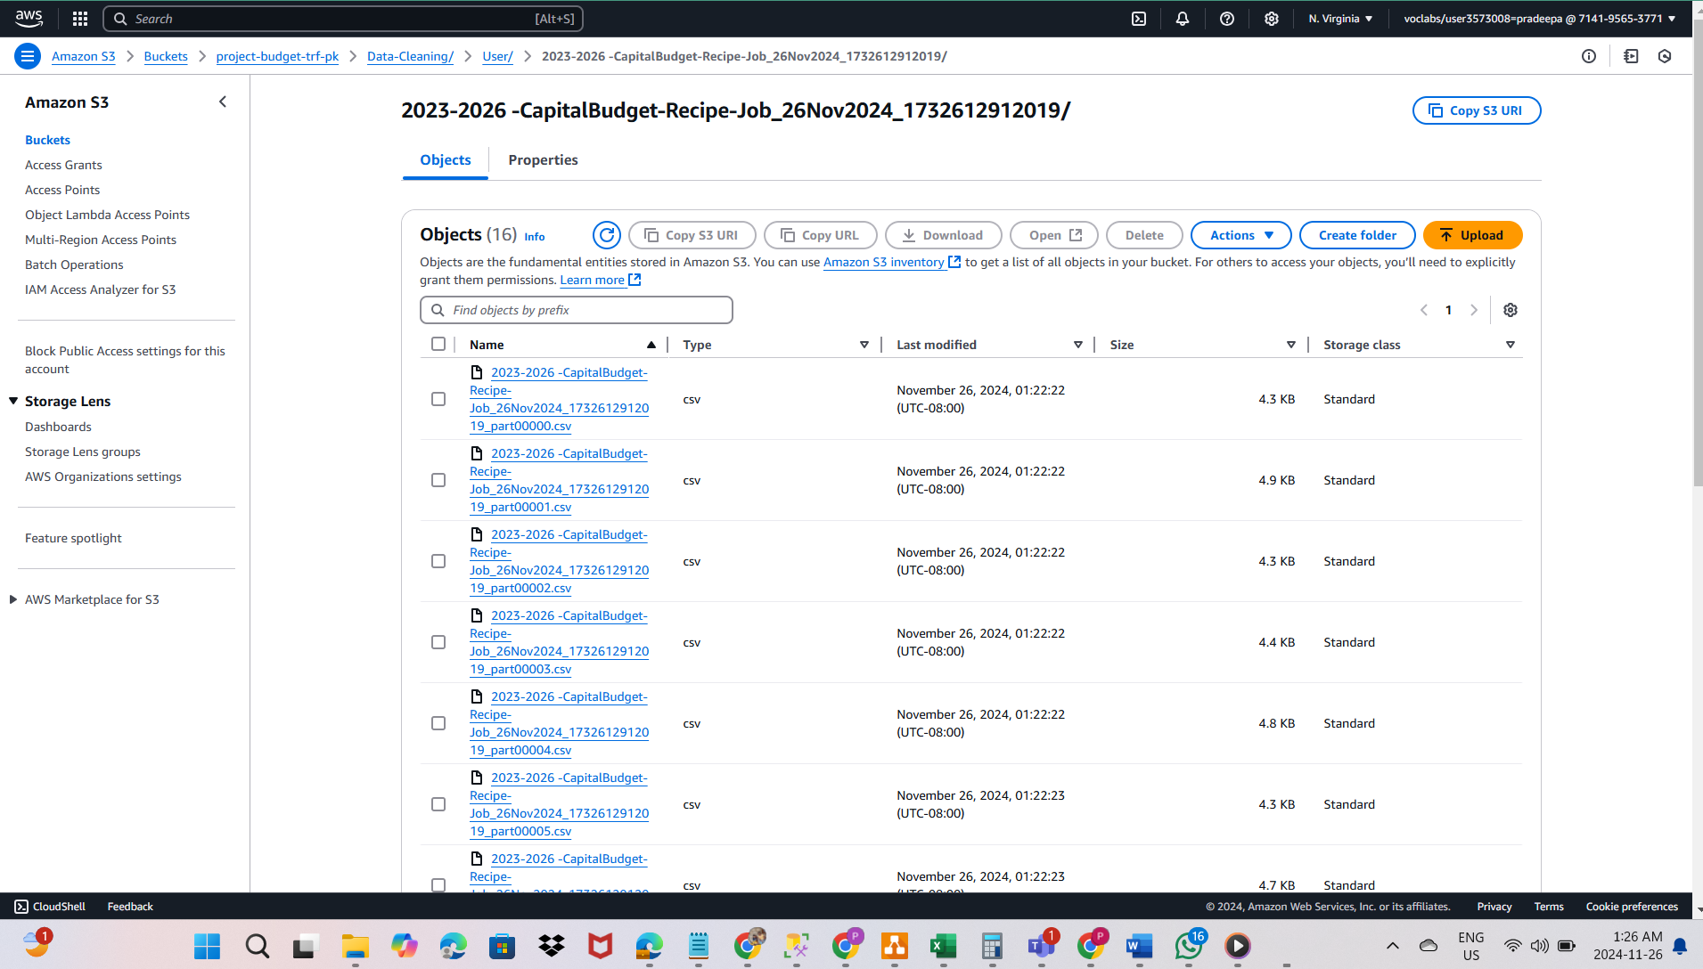

1. Data Transformation:
   * Convert data types (e.g., strings to datetime for dates, floats for costs).
   * Derive new features, such as year-wise total allocations or funding percentages.
   * Aggregate data to align with intended analyses (e.g., annual totals per category)

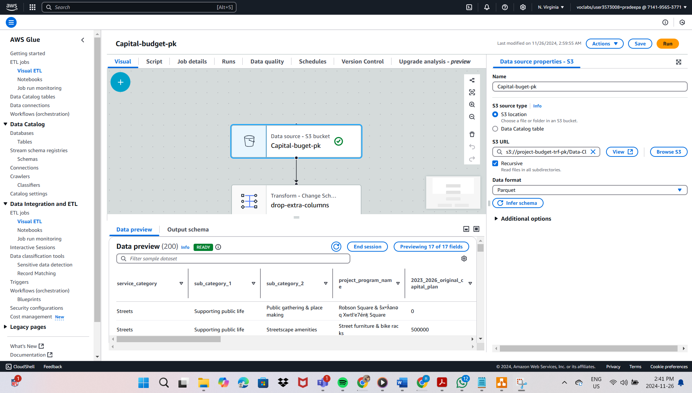

### Data Transformation:

Dropped additional unwanted columns.

Grouped and summed budget allocations by major expenditure categories (e.g., infrastructure, parks, transportation).

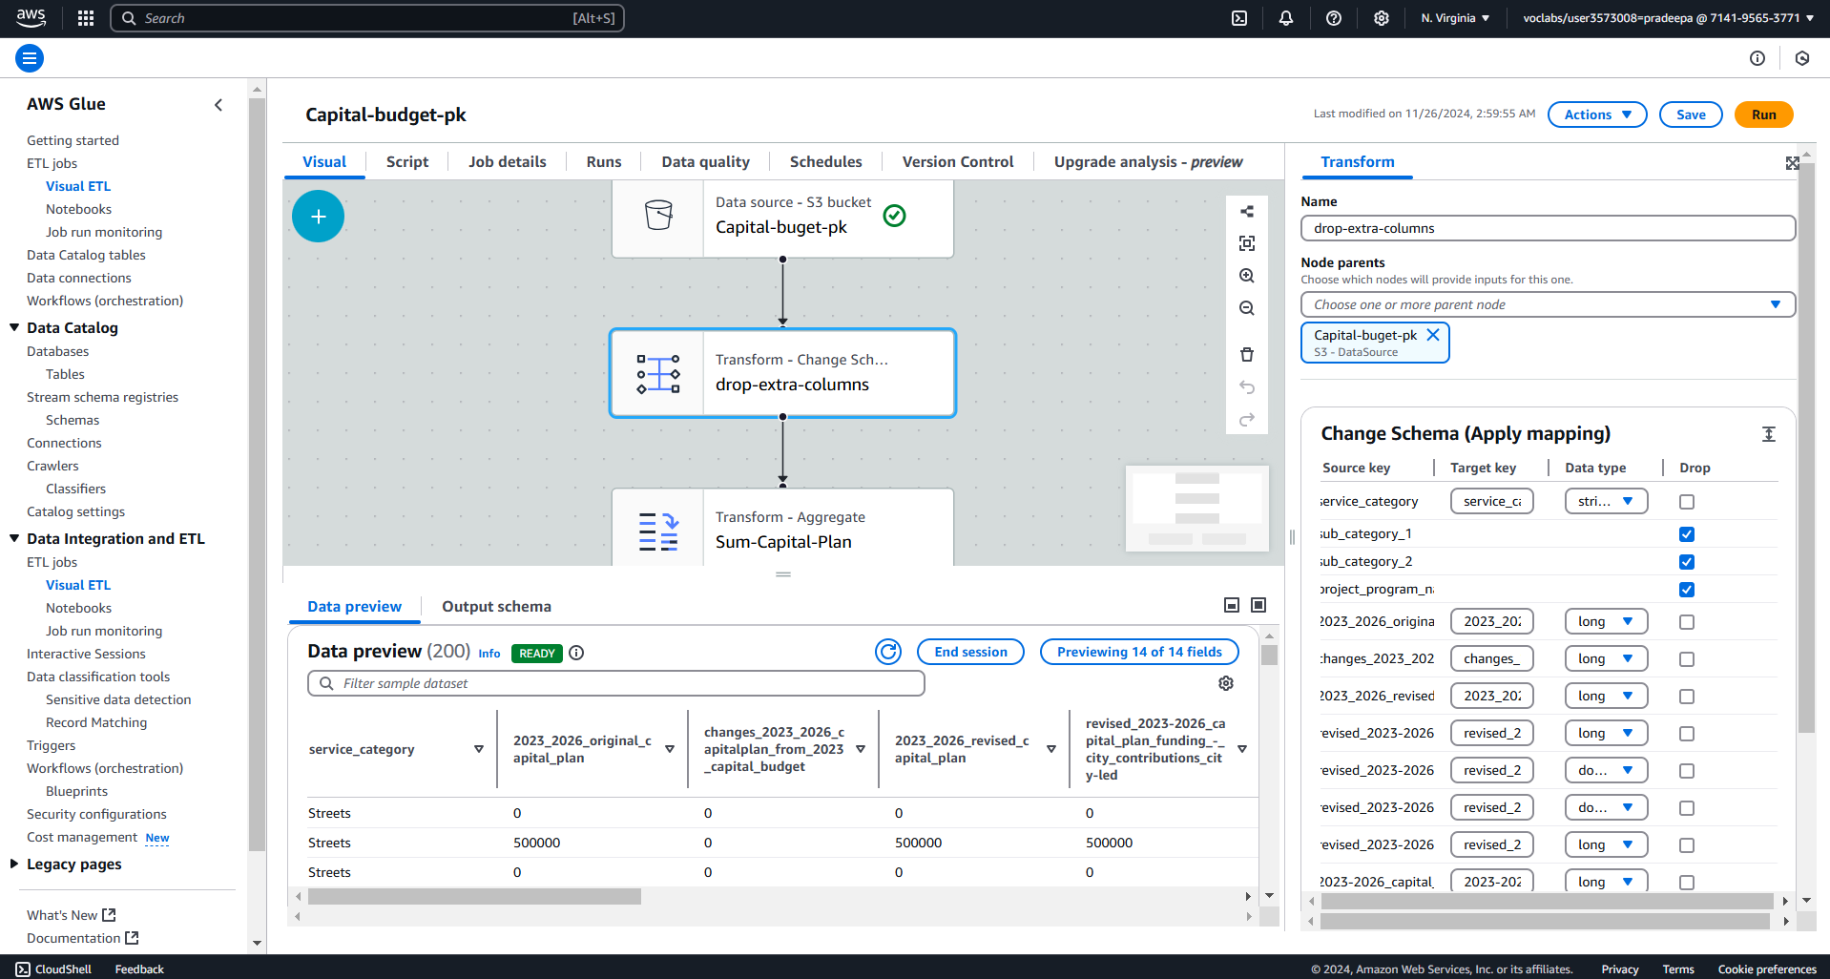

### Target Data Output:

Saved the transformed data in two formats:

CSV format for user-friendly access in the user S3 bucket.

Parquet format in a system bucket for optimized storage and computational efficiency.

This pipeline ensures that the data is clean, structured, and ready for analysis.

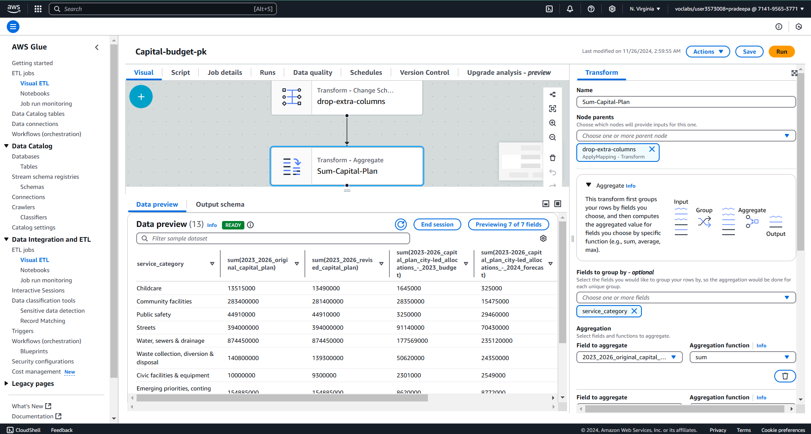

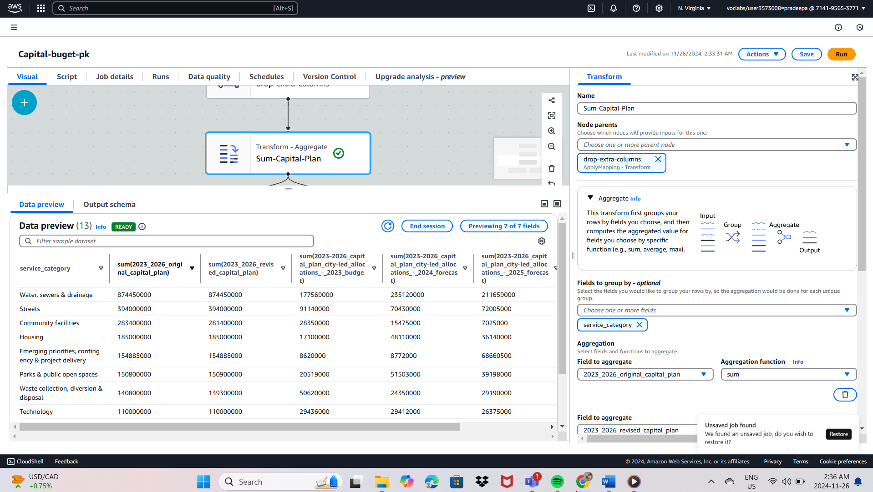

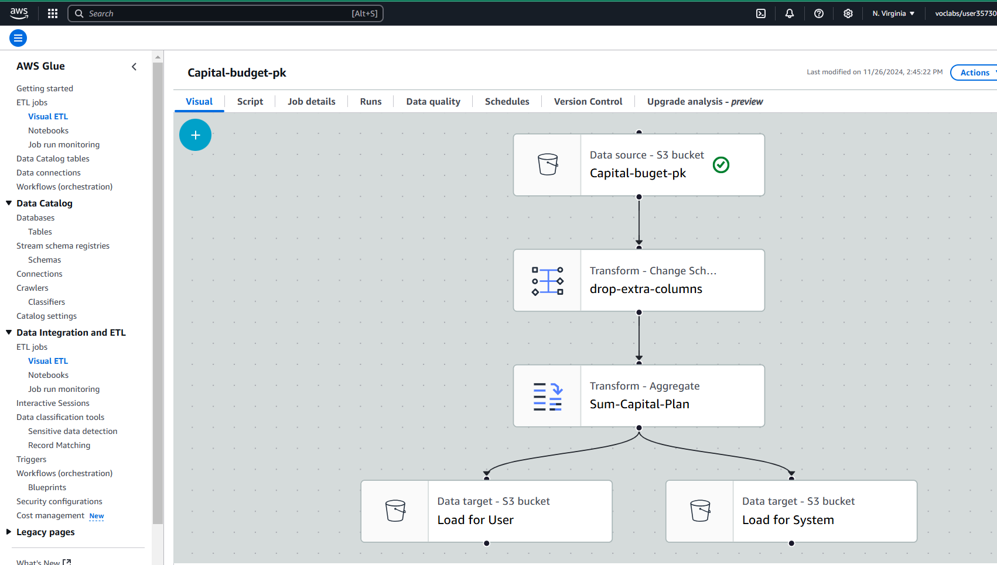

* 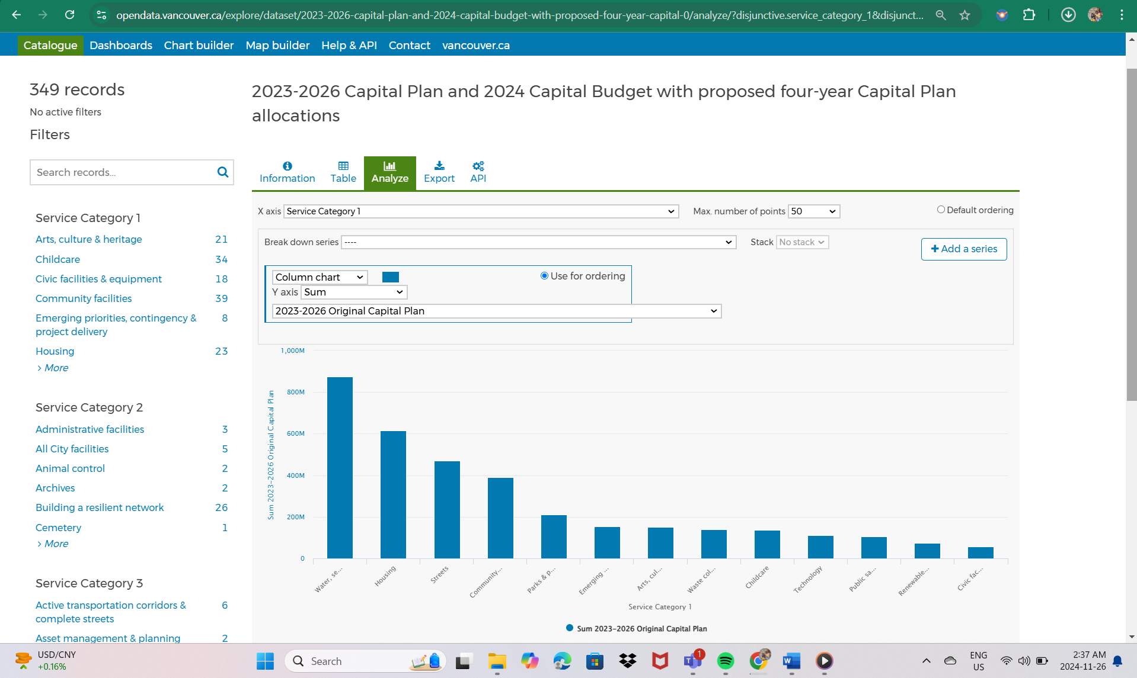

1. Data Consolidation:
   * Merge datasets, ensuring accurate linkage through unique identifiers (e.g., project ID).
   * Create a unified view of budget allocations and funding details.
2. Documentation and Validation:
   * Document the wrangling process, including data sources, cleaning methods, and transformations.
   * Validate the final dataset using exploratory data analysis (EDA) to confirm consistency and accuracy.

## Tools and Technologies:

* AWS S3: Centralized data storage.
* AWS DataBrew: Data profiling and cleaning.
* Python (Pandas, NumPy): Data manipulation and transformation.
* SQL: Data extraction and preparation from relational sources.
* Visualization Tools (Matplotlib, Seaborn): Validation and insights during the wrangling process.

## Deliverables:

* A cleaned, transformed dataset ready for analysis, available in both CSV and Parquet formats.
* A comprehensive report documenting the data wrangling process, including challenges, methods, and final dataset characteristics.
* Visualizations demonstrating data quality checks and key transformations.

## Timeline:

* Weeks 1–2: Data collection and profiling.
* Weeks 3–4: Cleaning and transformation.
* Weeks 5–6: Consolidation, validation, and documentation.

This data-wrangling initiative ensures that the City of Vancouver has a high-quality, consolidated dataset for capital budget analysis, enabling better resource allocation and financial planning for infrastructure, housing, and transportation projects.